|  |
| --- |
| Project: CY-UCC  Sub-Project: AIS  Trader Specs - Message Exchanges  EUROPEAN DYNAMICS  **May 2023** |

**Document History**

|  |  |  |  |
| --- | --- | --- | --- |
| **Version / Date** | **Author** | **Description** | **Action** |
| v0.1 – 20/12/2022 | ED | Initial Draft | C |
| v0.2 – 05/05/2023 | ED | Added AN/TS/PN messages  Added National Declaration messages | U |
| v0.3 – 19/05/2023 | ED | Revision of titles in all messages  Reorganization of the document  Added section with typical scenarios (9)  Added section with the high-level description of the B2G communication protocol (10) | U |

**Reviews**

|  |  |  |  |
| --- | --- | --- | --- |
| **Version / Date** | **Author** | **Description** | **Action** |
| v0.1 – 12/01/2023 | C&E | Review |  |

**Reference Documents**

| Ref. | Title | Reference | Version | Date |
| --- | --- | --- | --- | --- |
| R01 | CY-UCC-AIS Business Reengineering Document | CY-UCC-AIS-BRD | 1.1 | 02/11/2022 |
| R02 | CY-UCC-AIS System Design Document | CY-UCC-AIS-SDD | 0.2 | 12/05/2022 |
| R03 | Cyprus electronic Government Gateway - Integration System Interface - Message Specifications | D3-Department Integration System Interface Message Specifications.pdf | 3.0 | 05/11/2020 |

**Table of Contents**

1 Introduction 10

1.1 Purpose of the document 10

1.2 Intended Audience 10

1.3 Related documents 11

2 Datasets 12

2.1 Arrival Notification 12

2.2 Placement of Goods under Temporary Storage 12

2.3 Deconsolidation of Goods under Temporary Storage 13

2.4 Movement of Goods under Temporary Storage 14

2.5 Import 14

2.6 National Declaration for Excise Duties (ND1) 15

2.7 National Declaration for Means of Transport (ND2) 16

2.8 National Declaration for the Proof of Union Status (ND3) 17

2.9 Control and Business Case Management 18

2.10 Generic/Technical Messages 19

3 Arrival Notification 20

3.1 Messages 20

3.2 Use Cases 20

3.2.1 Arrival notification with ENS as previous document 20

3.2.2 Arrival notification without ENS as previous document 20

3.2.3 Arrival notification of means of transport without cargo 22

4 Temporary Storage 23

4.1 Placement of Goods under Temporary storage 23

4.1.1 Messages 23

4.1.2 Use Cases 23

4.2 Deconsolidation of Goods under Temporary Storage 41

4.2.1 Messages 41

4.2.2 Use Cases 42

4.3 Movement of Goods under Temporary Storage 43

4.3.1 Messages 43

4.3.2 Use Cases 44

5 Import 47

5.1 Messages 47

5.2 Release for free circulation – Use Cases 48

5.2.1 Standard Customs Declaration (H1, H5, H6, H7, I1) 48

5.2.2 Pre-lodged Standard Customs Declaration (H1, H6, H7, I1) 52

5.2.3 Simplified Customs Declaration 58

5.2.4 Simplified Customs Declaration with Supplementary Waiver 62

5.2.5 Pre-Lodged Simplified Customs Declaration 66

5.2.6 Pre-Lodged Simplified Customs Declaration with supplementary waiver 71

5.2.7 Supplementary Declaration 76

5.2.8 EIDR with PN and Supplementary Declaration (Type Z) 79

5.2.9 EIDR with PN waiver and Supplementary Declaration (Type Z) 82

5.2.10 Amendment of the Customs Declaration 85

5.2.11 Invalidation of the Customs Declaration 92

5.3 Special Procedures – Use Cases 99

5.3.1 Prior Import for Outward Processing 99

5.3.2 Placement - Standard Declaration for SP (H1, H2, H3, H4, I1) 104

5.3.3 Simplified and Supplementary Customs Declaration for SP 109

5.3.4 EIDR with PN and Supplementary Declaration (Type Z) 116

5.3.5 EIDR with PN waiver and Supplementary Declaration (Type Z) 119

5.4 Import Controls - Use Cases 122

5.4.1 Request Declaration Amendment 122

5.4.2 Request Declaration Invalidation 124

5.4.3 Request Document Presentation 125

5.4.4 Request Document Upload 126

5.5 Quota Allocation – Use Cases 127

5.5.1 Amendment notification for partial or deferred quota allocation 127

6 Excise Duty Declaration (ND1) 128

6.1 Messages 128

6.2 Use Cases 129

6.2.1 ND1 Declaration 129

6.2.2 Amendment to the ND1 Declaration 135

7 Means of Transport Declaration (ND2) 141

7.1 Messages 141

7.2 Use Cases 142

7.2.1 ND2 Means of Transport Declaration 142

7.2.2 Amendment to the ND2 Declaration 144

7.2.3 Invalidation of the ND2 Declaration 144

8 Proof of Union Status (ND3) 145

8.1 Messages 145

8.2 Use Cases 146

8.2.1 ND3 Declaration 146

8.2.2 Amendment to the ND3 Declaration 148

8.2.3 Invalidation of the ND3 Declaration 148

9 Typical scenarios for the Import of Goods 149

9.1 Non-Union Goods - standard procedure 149

9.1.1 Placement of Goods under Temporary Storage 149

9.1.2 Release Goods for free circulation 150

9.2 Union Goods – Standard Procedure 151

9.3 Postal and Courier Service Providers 152

9.3.1 Postal cargo with delivery at the Office of Exchange 152

9.3.2 Postal cargo with transfer from the Office of Exchange to the MSC 152

9.3.3 Couriers 153

10 Exchange of Messages 155

10.1 B2G Communication Protocol 155

10.1.1 Submission of the messages 156

10.1.2 Query of the status of a specific message 156

10.1.3 Query using the MRN 156

10.1.4 Message Downloading 156

**Table of Figures**

Figure 1: Declaration Invalidation Post release 93

Figure 2: Declaration Invalidation in [ACCEPTED] status 94

Figure 3: Declaration Invalidation in [REGISTERED] status 94

Figure 4: Declaration Invalidation in [UNDER_PAYMENT] status 95

Figure 5: Declaration Invalidation in [INSUFFICIENT_FUNDS] status 96

Figure 6: Declaration Invalidation in [RELEASED] status 96

Figure 7: B2G communication overview 155

**Table of Tables**

Table 1: Abbreviations and Acronyms 9

Table 2: Arrival Notification messages 12

Table 3: Temporary Storage messages 13

Table 4: Deconsolidation messages 13

Table 5: TSD Movement messages 14

Table 6: Import messages 15

Table 7Excise Duties messages 16

Table 8: Means of Transport messages 17

Table 9: Proof of Union Status messages 18

Table 10: Case Management messages 19

Table 11: Generic/Technical messages 19

**Abbreviations and Acronyms**

| Abbreviation | Meaning |
| --- | --- |
| AIS | Automated Import System |
| AN | Arrival Notification |
| BR | Business Rule |
| B2G | Business to Government |
| CA | Contracting Authority |
| CCI | Centralised Customs Clearance |
| CD | Customs Declaration |
| CM | Case Management |
| CSW-CERTEX | Customs Single Window – Certificates Exchange |
| CY-CAS | Cyprus Customs - Central Authentication Service |
| CY-UCC | Project for the National Implementation and Maintenance of UCC Customs System |
| C&E | Customs and Excise Department |
| DITS | Department of IT Services |
| ED | European Dynamics SA |
| EIDR | Entry in Declarant’s Records |
| EMCS | Excise Movement and Control System |
| ENS | Entry Summary Declaration |
| EORI | Economic Operator Registration and Identification |
| MRN | Movement Reference Number |
| MSC | Main Sorting Centre (of Cyprus Post) |
| NID | National Import Declaration |
| IT | Information Technology |
| PCI | Presentation Customs Office for Centralised Clearance for Import |
| PCO | Presentation Customs Office |
| PN | Presentation Notification |
| RA | Risk Analysis |
| RMS | Risk Management System |
| SCI | Supervising Customs Office for Centralised Clearance for Import |
| SCO | Supervising Customs Office |
| SP | Special Procedures |
| TS | Temporary Storage |
| TSD | Temporary Storage Declaration |
| T2L(F) | Customs document for the confirmation of Union status |
| UCC | Union Customs Code |

Table 1: Abbreviations and Acronyms

# Introduction

## Purpose of the document

The purpose of this document is to describe the information (messages) **Traders**[1] will be exchanging with the **Cyprus** **Customs** (Customs hereafter).

This document is divided into the following functional areas:

* Arrival Notification
* Placement of Goods under Temporary Storage
* Deconsolidation of Goods under Temporary Storage
* Movement of Goods under Temporary Storage
* Import (Release for free circulation, Special Procedures, Controls, Quota allocation)
* National Declarations (Excise Duties, Means of Transport, Proof of Union Status)

For each functional area, the document contains:

* A sequence diagram describing the messages exchanged between Traders and the Customs at a logical level, excluding the technical details.
* Summary Use Cases that describe the possible flows.
* Where possible, state transition diagrams have been included that show all possible states that a declaration can acquire during processing and the action/messages that cause the transition.

At the end of the document there is a list of Typical scenarios for the Import of Goods and a high-level description of the communication protocol for the Exchange of Messages.

## Intended Audience

The present document is intended to be read by the following people:

* CY-UCC Project Management Team
* CY-UCC-AIS Customs Experts
* ED Project Management Team
* ED IT Development Team
* Trader IT Development Teams

## Related documents

This document should be read in conjunction with the following documents:

|  |  |
| --- | --- |
| **Document name** | **Description** |
| CY-UCC-AIS-TRS Message Structures | Contains the logical structure of all messages exchanged between traders and the AIS Customs IT system |
| CY-UCC-AIS-TRS Codelists | Contains all codelists referred to within the message-structures document |
| CY-UCC-AIS-TRS Business Rules | Contains all business rules and conditions referred to within the message-structures document and applied during message validation |
| CY-UCC-AIS-TRS XSDs4Traders | Contains all message XSDs describing the business message content in XML |

# Datasets

The following tables contain the messages exchanged between Traders and the AIS IT system (e.g., temporary storage, special procedures, release for free circulation etc.).

The required data elements for each dataset, the structure of the data elements within each dataset, as well as the business rules that apply on them can be found in the “AIS Message-Structures” document.

## Arrival Notification

|  |  |  |  |
| --- | --- | --- | --- |
| **Message** | **Name** | **Sent by** | **Description** |
| AN215 | Arrival Notification | Trader | Trader submission of an Arrival Notification |
| AN216 | Arrival Notification Rejection | AIS | Informs Trader that the Arrival Notification is rejected |
| AN228 | Arrival Notification Acceptance | AIS | Informs Trader that the Arrival Notification is accepted |

Table 2: Arrival Notification messages

## Placement of Goods under Temporary Storage

|  |  |  |  |
| --- | --- | --- | --- |
| **Message** | **Name** | **Sent by** | **Description** |
| TS304 | Temporary Storage Declaration Amendment Request Registration | AIS | Informs Trader that the Temporary Storage Declaration Amendment request is accepted |
| TS305 | Temporary Storage Declaration Amendment Request Rejection | AIS | Informs Trader that the Temporary Storage Declaration Amendment request is rejected |
| TS309 | Temporary Storage Declaration Invalidation Decision | AIS | Notifies to the Trader the decision on the Invalidation Request |
| TS313 | Temporary Storage Declaration Amendment Request | Trader | Trader submission of a Temporary Storage Amendment request |
| TS314 | Temporary Storage Declaration Invalidation Request | Trader | Trader submission of a Temporary Storage Invalidation request |
| TS315 | Temporary Storage Declaration (G4), Combined Temporary Storage Declaration and Presentation Notification (G4+G3), National Declaration of Union Goods (Manifest) | Trader | Trader submission of Temporary Storage Declaration (G4 or G4+G3), or a national declaration for the import of Union Goods (Manifest) |
| TS315V | [G4 | G4+G3 | Manifest] Declaration Registration | AIS | Informs Trader that the [G4 | G4+G3 | Manifest] Declaration is registered |
| TS316 | [G4 | G4+G3 | Manifest] Declaration Rejection | AIS | Informs Trade that the [G4 | G4+G3 | Manifest] Registration is rejected (Validation Failed) |
| TS328 | [G4 | G4+G3 | Manifest] Declaration Acceptance | AIS | Informs Trader that the [G4 | G4+G3 | Manifest] Declaration Registration is accepted |
| TS332 | Presentation Notification (G3) | Trader | Trader submission of a (G3) Presentation Notification |
| TS333 | Presentation Notification (G3) Rejection | AIS | Informs Trader that the (G3) Presentation Notification is rejected (Validation Failed) |
| TS351 | [G4 | G4+G3 | Manifest] Refusal | AIS | Informs Trader that the [G4 | G4+G3 | Manifest] Declaration is refused (Post Validation) |
| TS370 | Goods Status Report Declaration (ND4) | Trader | Temporary Storage Administrator reports on the status of the unloaded goods |

Table 3: Temporary Storage messages

## Deconsolidation of Goods under Temporary Storage

|  |  |  |  |
| --- | --- | --- | --- |
| **Message** | **Name** | **Sent by** | **Description** |
| ND515 | Deconsolidation Declaration (ND5) | Trader | Trader submission of a deconsolidation request |
| ND516 | Deconsolidation Declaration Rejection | AIS | Notifies the Trader that the deconsolidation request is rejected |
| ND528 | Deconsolidation Declaration Acceptance | AIS | Notifies the Trader that the deconsolidation request is accepted |

Table 4: Deconsolidation messages

## Movement of Goods under Temporary Storage

|  |  |  |  |
| --- | --- | --- | --- |
| **Message** | **Name** | **Sent by** | **Description** |
| TS515 | Request to move goods under TS | Trader | Sending Trader requests permission to move goods under temporary storage |
| TS516 | Rejection of request to move goods under TS | AIS | Informs Trader that the move request is rejected |
| TS528 | Acceptance of request to move goods under TS | AIS | Informs Trader that the move request is accepted |
| TS501 | Declaration of Movement of Goods under Temporary Storage (G5) | Trader | Receiving Trader notifies the movement of goods under temporary storage |
| TS506 | G5 Declaration Rejection | AIS | Informs Trader that the G5 declaration is rejected |
| TS508 | G5 Declaration Acceptance | AIS | Informs Trader that the G5 declaration is accepted |

Table 5: TSD Movement messages

## Import

|  |  |  |  |
| --- | --- | --- | --- |
| **Message** | **Name** | **Sent by** | **Description** |
| IM404 | Declaration Amendment Acceptance | AIS | SCI informs Trader that the Amendment Request is accepted |
| IM405 | Amendment Request Rejection | AIS | Informs Trader that the Amendment Request is rejected |
| IM409 | Invalidation Request Decision | AIS | Notifies to the Trader the decision on the Invalidation Request |
| IM410 | Invalidation of Customs Declaration | AIS | SCI notifies to the Trader the invalidation of the Customs Declaration |
| IM413 | Customs Declaration Amendment | Trader | Trader submission of a Customs Declaration Amendment Request |
| IM414 | Invalidation Request | Trader | Trader submission of a Customs Declaration Invalidation Request |
| IM415 | Customs Declaration | Trader | Trader submission of an Import Customs Declaration |
| IM415V | Customs Declaration Acknowledgment | AIS | Informs Trader of Pre-lodged Customs Declaration Registration |
| IM416 | Customs Declaration Rejection | AIS | Informs Trader that the Customs Declaration is rejected (Validation Failed) |
| IM426 | Registration Notification | AIS | SCI informs Trader that the Customs Declaration is registered |
| IM428 | Acceptance of Customs Declaration | AIS | SCI informs Trader that the Customs Declaration is accepted |
| IM429 | Release For Import | AIS | SCI informs Trader that goods can be released |
| IM431 | Expiration of Timer for Supplementary Declaration Notification | AIS | SCI informs Trader that the timer for the submission of the supplementary declaration has expired |
| IM432 | Presentation Notification (I2) | Trader | Trader submission of a (I2) Presentation Notification |
| *IM433* | *Entry into the Declarant Records* | *Trader* | *Note: CCI phase 2 only* |
| IM451 | No Release | AIS | SCI informs Trader that the goods cannot be released |
| IM456 | Rejection from SCI | AIS | SCI informs Trader that the declaration has been rejected |
| IM457 | Presentation Notification Registration | AIS | Inform Trader that the PN has been registered |
| IM493 | Amendment notification for partial or deferred quota allocation | AIS | Informs Trader of a Declaration Amendment effected by the system due to a Quota allocation response. |
| IM933 | Presentation Notification (I2) Rejection | AIS | Informs Trade of (I2) Presentation Notification Rejection |

Table 6: Import messages

## National Declaration for Excise Duties (ND1)

|  |  |  |  |
| --- | --- | --- | --- |
| **Message** | **Name** | **Sent by** | **Description** |
| ND104 | Excise Duties Declaration Amendment Request Registration | AIS | Informs Trader that the Excise Duties Declaration Amendment request is accepted |
| ND105 | Excise Duties Declaration Amendment Request Rejection | AIS | Informs Trader that the Excise Duties Declaration Amendment request is rejected |
| ND109 | Excise Duties Declaration Invalidation Decision | AIS | Notifies to the Trader the decision on the Invalidation Request |
| ND113 | Excise Duties Declaration Amendment Request | Trader | Trader submission of an Excise Duties Amendment request |
| ND114 | Excise Duties Declaration Invalidation Request | Trader | Trader submission of an Excise Duties Invalidation request |
| ND115 | Excise Duties Declaration (ND1) | Trader | Trader submission of an Excise Duties declaration (ND1) |
| ND116 | ND1 Declaration Rejection | AIS | Informs Trader that the ND1 Declaration Registration is rejected (Validation Failed) |
| ND128 | ND1 Declaration Acceptance | AIS | Informs Trader that the ND1 Declaration Registration is accepted |
| ND129 | ND1 Declaration Release Notification | AIS | Informs Trader that the ND1 Declaration can be Released |
| ND151 | ND1 Declaration Release Refusal | AIS | Informs Trader that the ND1 Declaration is refused (release refused) |

Table 7Excise Duties messages

## National Declaration for Means of Transport (ND2)

|  |  |  |  |
| --- | --- | --- | --- |
| **Message** | **Name** | **Sent by** | **Description** |
| ND204 | Means of Transport Declaration Amendment Request Registration | AIS | Informs Trader that the Means of Transport Declaration Amendment request is accepted |
| ND205 | Means of Transport Declaration Amendment Request Rejection | AIS | Informs Trader that the Means of Transport Declaration Amendment request is rejected |
| ND209 | Means of Transport Declaration Invalidation Decision | AIS | Notifies to the Trader the decision on the Invalidation Request |
| ND213 | Means of Transport Declaration Amendment Request | Trader | Trader submission of a Means of Transport Amendment request |
| ND214 | Means of Transport Declaration Invalidation Request | Trader | Trader submission of a Means of Transport Invalidation request |
| ND215 | Means of Transport Declaration (ND2) | Trader | Trader submission of a Means of Transport declaration (ND2) |
| ND216 | ND2 Declaration Rejection | AIS | Informs Trader that the ND2 Declaration is rejected (Validation Failed) |
| ND228 | ND2 Declaration Acceptance | AIS | Informs Trader that the ND2 Declaration is accepted |
| ND229 | ND2 Declaration Release Notification | AIS | Informs Trader that the ND2 Declaration is released |
| ND251 | ND2 Declaration Release Refusal | AIS | Informs Trader that the ND2 Declaration is refused (release refused) |

Table 8: Means of Transport messages

## National Declaration for the Proof of Union Status (ND3)

|  |  |  |  |
| --- | --- | --- | --- |
| **Message** | **Name** | **Sent by** | **Description** |
| ND304 | Proof of Union Status Declaration Amendment Request Registration | AIS | Informs Trader that the Proof of Union Status Declaration Amendment request is accepted |
| ND305 | Proof of Union Status Declaration Amendment Request Rejection | AIS | Informs Trader that the Proof of Union Status Declaration Amendment request is rejected |
| ND309 | Proof of Union Status Declaration Invalidation Decision | AIS | Notifies to the Trader the decision on the Invalidation Request |
| ND313 | Proof of Union Status Declaration Amendment Request | Trader | Trader submission of a Proof of Union Status Amendment request |
| ND314 | Proof of Union Status Declaration Invalidation Request | Trader | Trader submission of a Proof of Union Status Invalidation request |
| ND315 | Proof of Union Status (ND3) | Trader | Trader submission of a Proof of Union Status declaration (ND3) |
| ND316 | ND3 Declaration Rejection | AIS | Informs Trader that the ND3 Declaration is rejected (Validation Failed) |
| ND328 | ND3 Declaration Acceptance | AIS | Informs Trader for the ND3 Declaration is accepted |
| ND329 | ND3 Declaration Release Notification | AIS | Informs Trader that the ND3 Declaration is released |
| ND351 | ND3 Declaration Release Refusal | AIS | Informs Trader that the ND3 Declaration is refused (release refused) |

Table 9: Proof of Union Status messages

## Control and Business Case Management

|  |  |  |  |
| --- | --- | --- | --- |
| **Message** | **Name** | **Sent by** | **Description** |
| IM438 | Reminder for providing additional documents | AIS | SCI reminds the Trader that the Supporting Documents are not yet received |
| IM444 | Control Results | AIS | SCI notifies the Trader about the control results |
| IM446 | Provide Supporting Documents | Trader | The Trader provides the supporting documents to the SCI |
| IM447 | Documentary Control Results | AIS | SCI notifies the Trader about the documentary control results |
| IM460 | Control Notice | AIS | SCI informs Trader of intended controls to be performed at PCO |
| IM462 | Request Presentation Notification | AIS | Request Presentation Notification from the Trader |
| IM464 | Request Declaration Invalidation | AIS | Informs Trader that a Declaration Invalidation is required by Customs |
| IM482 | Documents Request | AIS | Informs Trader that additional Documents are required by Customs |
| IM483 | Documents Received | Trader | Trader submission of Customs requested additional documents |
| IM484 | Request Document Presentation | AIS | Informs Trader that specific Documents must be presented to Customs in paper (originals) form. |
| IM882 | Documents Upload Request Cancellation | AIS | Informs Trader that a previously issued Documents Upload Request by Customs has been retracted. |
| IM884 | Documents Presentation Request Cancellation | AIS | Informs Trader that a previously issued Documents Presentation Request by Customs has been retracted. |
| IM862 | Declaration Amendment Request Cancellation | AIS | Informs Trader that a previously issued Declaration Amendment Request by Customs has been retracted. |
| IM864 | Declaration Invalidation Request Cancellation | AIS | Informs Trader that a previously issued Declaration Invalidation Request by Customs has been retracted. |
| IM962 | Request Declaration Amendment | AIS | Requests Trader to submit an Amendment Declaration |

Table 10: Case Management messages

## Generic/Technical Messages

|  |  |  |  |
| --- | --- | --- | --- |
| **Message** | **Name** | **Sent by** | **Description** |
| IM099 | General Notification and Request Information | AIS | Generic (multi-purpose) informational message |
| IM917 | Syntax Error notification message | AIS | Informs Trader of submitted message Syntax (Structural) Error(s) |

Table 11: Generic/Technical messages

# Arrival Notification

An arrival notification is mandatory for all sea-going vessels or aircrafts entering the Cyprus Customs territory.

## Messages

See 2.1 and 2.10

## Use Cases

### Arrival notification with ENS as previous document

When the arrival notification has an ENS declaration as previous document it must be submitted **only** via the ICS2 Shared Trader Interface (central system).

**Note:** This is currently the case for all air means of transport. Maritime means of transport will be included with the start of ICS2 release 3.

### Arrival notification without ENS as previous document

All means of transport that arrive in the Cyprus Customs territory and are not obliged to submit an ENS declaration, shall submit their arrival notification via the AIS IT system (message AN215).

Carriers or their representatives shall indicate the type of their cargo using one or more of the following indicators:

* **Goods remaining on board**
* **Union Goods**
* **Non-Union Goods**

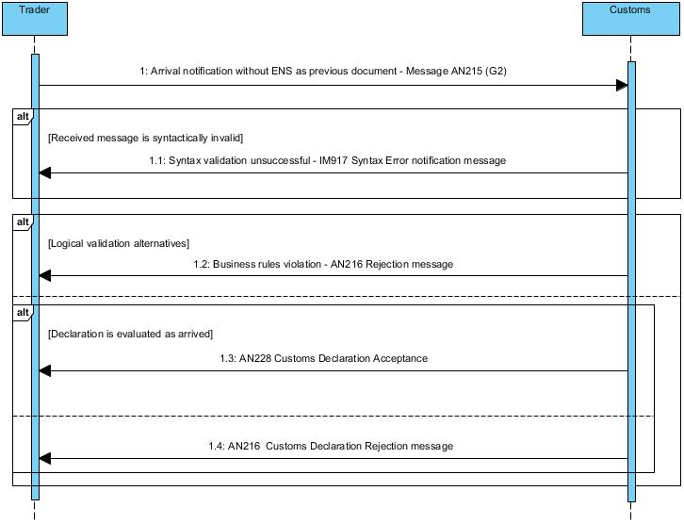

**Core Flow (Happy Path) - Reception of an Arrival Notification**

1. AIS receives an AN215 (G2) message
2. AN215 (G2) is syntactically valid
3. AN215 (G2) is logically valid (No business rules violation)
4. AIS sends AN228 (including the MRN)
5. The G2 declaration status is set to [ACCEPTED]

**Alt 1 – AN215** **(G2)** **is syntactically invalid**

1. AIS receives an AN215 (G2) message
2. AN15 (G2) message is syntactically invalid
3. AIS sends an IM917 Syntax Error Notification message to the Trader

**Alt 2 – AN215** **(G2)** **is logically invalid**

1. The process follows the core flow up to step 2
2. AN215 (G2) message is logically invalid (Business rules violation)
3. AIS sends the AN216 rejection message to the Trader
4. The G2 declaration status is set to [REJECTED]

### Arrival notification of means of transport without cargo

Carriers or their representatives shall submit their arrival notification (message AN215) by selecting **only** the “**Nil-Cargo**” indicator.

The message exchange flow remains as explained in the previous paragraph.

# Temporary Storage

Non-Union goods shall be in temporary storage from the moment they are presented to Customs.

## Placement of Goods under Temporary storage

### Messages

See 2.2, 2.9, and 2.10

### Use Cases

#### Separate Temporary Storage Declaration (G4) and Presentation Notification of the goods (G3)

Traders can submit the temporary storage declaration (G4) before the presentation of the goods to Customs. In that case, the presentation notification (G3) shall be submitted separately. The presentation notification shall indicate (as previous document) the MRN of the associated arrival notification.

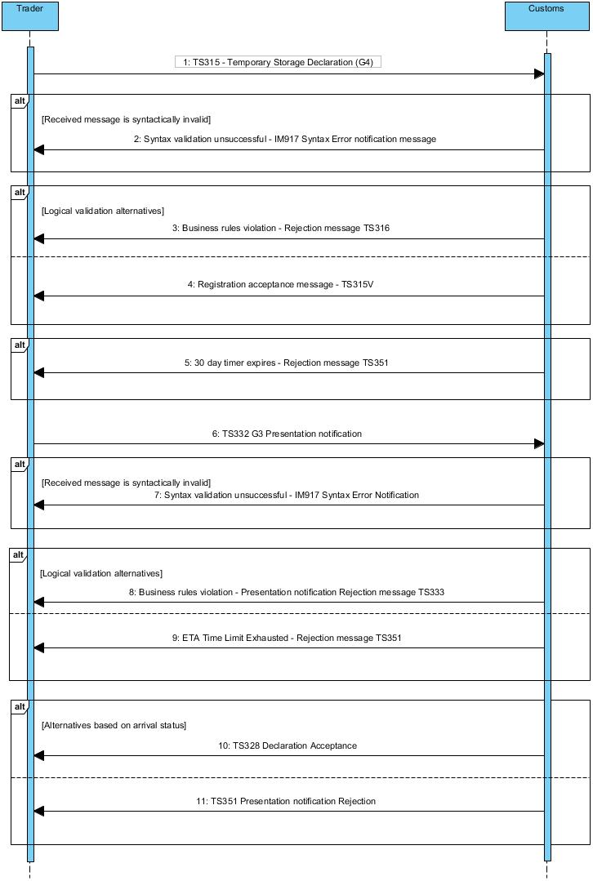

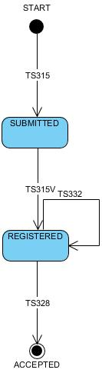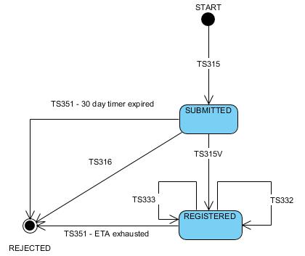

**Core Flow (Happy Path) – Reception of Temporary Storage (G4) declaration before the Presentation Notification (G3)**

1. AIS receives a TS315 message (G4)
2. The TS315 message is syntactically valid
3. The TS315 message is logically valid (No business rules violation)
4. The G4 declaration is “registered”
5. AIS sends a TS315V message (including the MRN)
6. The G4 declaration is set to status [REGISTERED]
7. AIS receives a TS332 message (G3 presentation notification)
8. The TS332 message is syntactically valid
9. The TS332 message is logically valid (No business rules violation)
10. AIS checks the arrival status of the declaration
11. The means of transport has arrived
12. AIS sends a TS328 acceptance message to the Trader
13. The G4 declaration is set to status [ACCEPTED]

**Alt 1 – The Temporary Storage Declaration (G4) is syntactically invalid**

1. The process follows the core flow up to step 1
2. The TS315 message is syntactically invalid
3. AIS sends an IM917 Syntax Error Notification message to the Trader

**Alt 2 – The Temporary Storage Declaration (G4) is logically invalid**

1. The process follows the core flow up to step 2
2. The TS315 message is logically invalid (Business rules violation)
3. AIS sends a TS316 rejection message to the Trader
4. The G4 Declaration is set to status [REJECTED]

**Alt 3 – The Temporary Storage Declaration (G4) 30-day timer expires**

1. The process follows the core flow up to step 6
2. The 30-days timer has expired
3. AIS sends a TS351 rejection message to the Trader (invalidation, according to UCC article 146 2(b)).
4. The G4 Declaration is set to status [INVALIDATED]

**Alt 4 – The Presentation Notification (G3) is syntactically invalid**

1. The process follows the core flow up to step 7
2. The TS332 message is syntactically invalid
3. AIS sends an IM917 Syntax Error Notification message to the Trader

**Alt 5 – The Presentation Notification (G3) is logically invalid**

1. The process follows the core flow up to step 8
2. The TS332 message is logically invalid (Business rules violation)
3. AIS sends a TS333 rejection message to the Trader
4. The G3 Declaration is set to status [REJECTED]

**Alt 7 – The Presentation Notification (G3) contains an invalid Arrival Notification reference**

1. The process follows the core flow up to step 10
2. The arrival notification reference is not valid
3. AIS sends a TS333 rejection message to the Trader
4. The G3 Declaration is set to status [REJECTED]

#### Combined Temporary Storage Declaration and Presentation Notification (G4+G3)

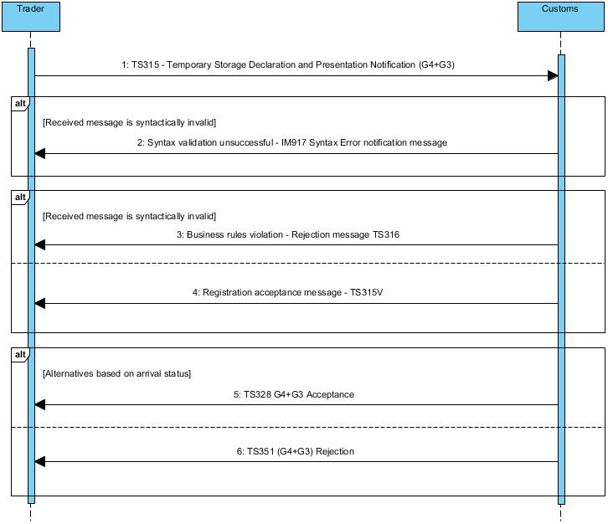



**Core Flow (Happy Path) – Reception of combined Temporary Storage Declaration and Presentation Notification (G4+G3)**

1. AIS receives an TS315 (G4+G3) message
2. The TS315 message is syntactically valid
3. The TS315 message is logically valid (No business rules violation)
4. AIS sends a TS315V message (including the MRN)
5. The G4+G3 declaration status is set to [REGISTERED]
6. AIS checks the arrival status of the declaration
7. The arrival notification reference is valid
8. AIS sends a TS328 acceptance message to the Trader
9. The G4+G3 declaration status is set to [ACCEPTED]

**Alt 1 – The TS315** **(G4+G3) message** **is syntactically invalid**

1. The process follows the core flow up to step 1
2. The TS315 message is syntactically invalid
3. AIS sends a IM917 Syntax Error Notification message to the Trader

**Alt 2 – The TS315** **(G4+G3) message** **is logically invalid**

1. The process follows the core flow up to step 2
2. The TS315 message is logically invalid (Business rules violation)
3. AIS sends a TS316 rejection message to the Trader
4. The G4+G3 declaration status is set to [REJECTED]

**Alt 3 – The TS315 (G4+G3) message contains an invalid Arrival Notification reference**

1. The process follows the core flow up to step 6
2. The arrival notification reference is not valid
3. AIS sends a TS351 message to the Trader
4. The G4+G3 declaration status is set to [NOT RELEASED]

#### Status of Goods placed under Temporary Storage (ND4)

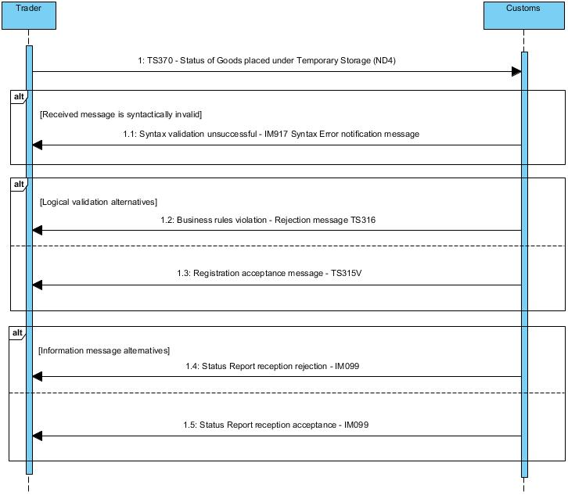

**Core Flow (Happy Path) – Reception of the Status of Goods placed under Temporary Storage**

1. AIS receives an TS370 (ND4) message
2. The TS370 message is syntactically valid
3. The TS370 message is logically valid
4. The TS370 message is attached to the referenced G4 (or G4+G3) temporary storage declaration
5. AIS sends an IM099 information message to the Trader, indicating that the status report was received successfully.

**Alt 1 – The TS370** **(ND4) message** **is syntactically invalid**

1. The process follows the core flow up to step 1
2. The TS370 message is syntactically invalid
3. AIS sends a IM917 Syntax Error Notification message to the Trader

**Alt 2 – The TS370** **(ND4) message** **is logically invalid**

1. The process follows the core flow up to step 2
2. The TS370 message is logically invalid (Business rules violation, invalid G4/G4+G3 reference, duplicate, etc.)
3. AIS sends an IM099 information message to the Trader, indicating that the status report was not accepted.

#### Amendment to a registered (G4) Temporary Storage Declaration

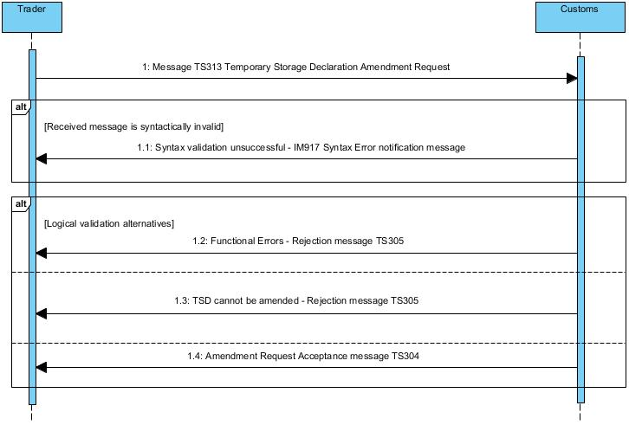

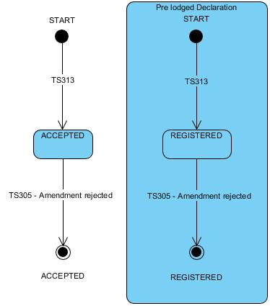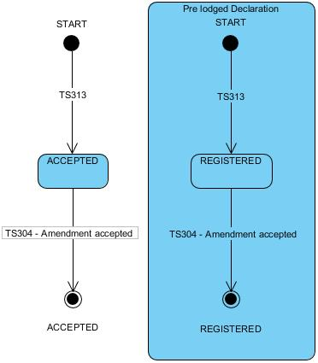

**Core Flow (Happy Path) - Amendment request accepted**

1. AIS receives a TS313 message for a G4 declaration that is in status “REGISTERED”
2. The message is syntactically valid
3. The message is logically valid (No business rules violation)
4. The Amendment request is accepted automatically
5. AIS sends a TS304 notification message to the Trader
6. The amended G4 declaration remains in status “REGISTERED”.

**Alt 1 - The Amendment request is syntactically invalid**

1. The process follows the core flow up to step 1
2. The TS313 message is syntactically invalid
3. AIS sends an IM917 Syntax Error Notification message to the Trader
4. The previous G4 declaration remains in status “REGISTERED”.

**Alt 2 - Amendment request rejected - functional errors**

1. The process follows the core flow up to step 2
2. The TS313 message has functional errors
3. AIS sends a TS305 rejection message to the Trader
4. The previous G4 declaration remains in status “REGISTERED”

**Alt 3 - Amendment request rejected - TSD Cannot be amended**

1. The process follows the core flow up to step 3
2. The TSD cannot be amended
3. AIS sends a TS305 rejection message to the Trader

#### Amendment to an accepted (G4 or G4+G3) Temporary Storage Declaration

**Core Flow (Happy Path) - Amendment request accepted**

1. AIS receives a TS313 message for a G4 (or G4+G3) declaration that is in status “ACCEPTED”
2. The message is syntactically valid
3. The message is logically valid (No business rules violation)
4. The Amendment request is accepted by a Customs Officer
5. AIS sends a TS304 notification message to the Trader
6. The amended G4 (or G4+G3) declaration remains in status “ACCEPTED”

**Alt 1 - The Amendment request is syntactically invalid**

1. The process follows the core flow up to step 1
2. The TS313 message is syntactically invalid
3. AIS sends an IM917 Syntax Error Notification message to the Trader
4. The previous G4 (or G4+G3) declaration remains in status “ACCEPTED”.

**Alt 2 - Amendment request rejected - functional errors**

1. The process follows the core flow up to step 2
2. The TS313 message has functional errors
3. AIS sends a TS305 rejection message to the Trader
4. The previous G4 (or G4+G3) declaration remains in status “ACCEPTED”.

**Alt 3 - Amendment request refused**

1. The process follows the core flow up to step 3
2. The Amendment is not accepted by the Customs Officer
3. AIS sends a TS305 rejection message to the Trader
4. The previous G4 (or G4+G3) declaration remains in status “ACCEPTED”.

#### Invalidation of a registered (G4) Temporary Storage Declaration

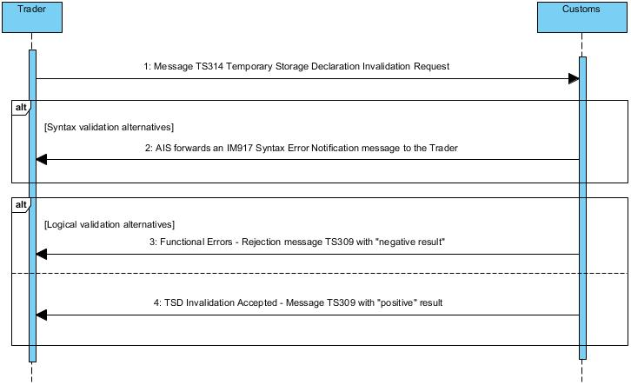

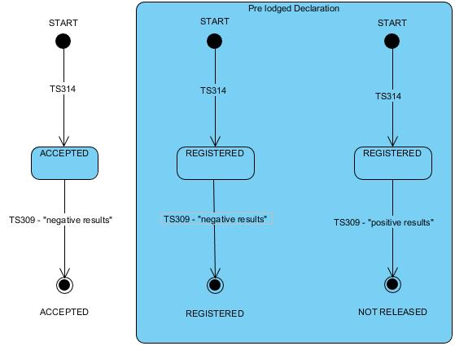

**Core Flow (Happy Path) - Invalidation request accepted**

1. AIS receives a TS314 message for a G4 declaration in status “REGISTERED”
2. The TS314 message is syntactically valid
3. The TS314 message is logically valid (No business rules violation)
4. The Invalidation request is accepted automatically
5. AIS sends a TS309 notification message to the Trader with “Positive” result
6. The G4 declaration is set to status “INVALIDATED”

**Alt 1 - The Invalidation request is syntactically invalid**

1. The process follows the core flow up to step 1
2. The TS314 message is syntactically invalid
3. AIS sends an IM917 Syntax Error Notification message to the Trader
4. The G4 declaration remains in status “REGISTERED”

**Alt 2 – The Invalidation request is logically invalid**

1. The process follows the core flow up to step 2
2. The TS314 message has logical validation errors
3. AIS sends a TS309 notification message to the Trader with “Negative” result
4. The G4 declaration remains in status “REGISTERED”

#### Invalidation of an accepted (G4 or G4+G3) Temporary Storage Declaration



**Core Flow (Happy Path) - Invalidation request accepted**

1. AIS receives a TS314 message for a G4 declaration in status “ACCEPTED”
2. The TS314 message is syntactically valid
3. The TS314 message is logically valid (No business rules violation)
4. The Invalidation request is accepted by a Customs Officer
5. AIS sends a TS309 notification message to the Trader with “Positive” result
6. The G4 (or G4+G3) declaration is set to status “INVALIDATED”

**Alt 1 - The Invalidation request is syntactically invalid**

1. The process follows the core flow up to step 1
2. The TS314 message is syntactically invalid
3. AIS sends an IM917 Syntax Error Notification message to the Trader
4. The G4 (or G4+G3) declaration remains in status “ACCEPTED”

**Alt 2 – The Invalidation request is logically invalid**

1. The process follows the core flow up to step 2
2. The TS314 message has logical validation errors
3. AIS sends a TS309 notification message to the Trader with “Negative” result
4. The G4 (or G4+G3) declaration remains in status “ACCEPTED”

**Alt 3 – The Invalidation request is refused**

1. The process follows the core flow up to step 3
2. The Invalidation request is refused by a Customs Officer
3. AIS sends a TS309 notification message to the Trader with “Negative” result
4. The G4 (or G4+G3) declaration remains in status “ACCEPTED”

#### End of Temporary Storage

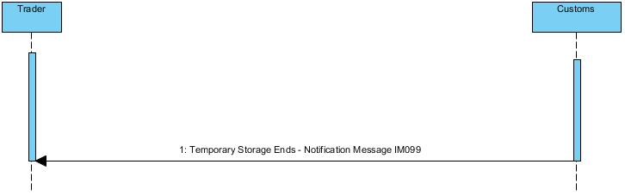

**Core Flow (Happy Path) - Temporary Storage 90-days timer expires**

1. The 90-days timer has expired
2. The Temporary Storage Declaration is set to status “EXPIRED”
3. AIS sends an IM099 notification message to the Trader

## Deconsolidation of Goods under Temporary Storage

The deconsolidation process allows traders to declare the detailed contents of the Goods that had been placed under Temporary Storage.

The deconsolidation concerns either one single Master Consignment Item or one House Consignment (of an already accepted Temporary Storage Declaration). The deconsolidated items will be one or more House Consignments.

The deconsolidation process is always subject to Customs approval. After the approval, the original items are removed from the Temporary Storage and they are replaced with the new (deconsolidated) items. The new items will take over the remaining time of the 90-days timer of the original item.

### Messages

See 2.3 and 2.10

### Use Cases

#### Deconsolidation of a Master Consignment Item or a House Consignment

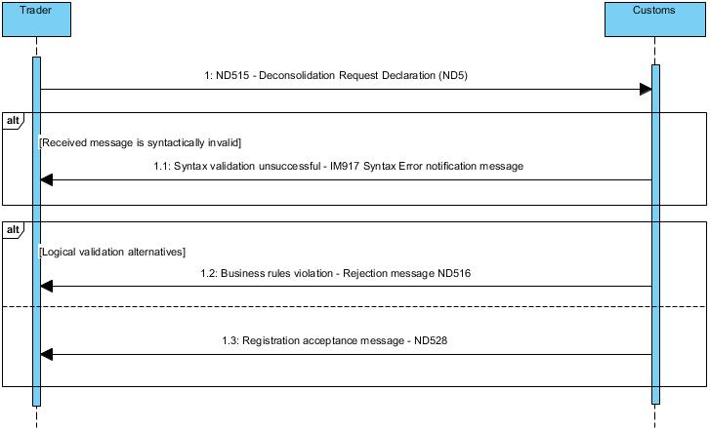

**Core Flow (Happy Path) – Deconsolidation Request is processed successfully**

1. AIS receives a ND515 message for a ND5 declaration
2. The ND515 message is syntactically valid
3. The ND515 message is logically valid (No business rules violation)
4. The deconsolidation request is accepted by a Customs Officer
5. The Master Consignment Item (or the House Consignment) is replaced by the new House Consignment(s) announced in the ND5 declaration
6. AIS sends a ND528 acceptance message to the Trader
7. The ND5 declaration is set to status “ACCEPTED”

**Alt 1 - The deconsolidation request is syntactically invalid**

1. The process follows the core flow up to step 1
2. The ND515 message is syntactically invalid
3. AIS sends an IM917 Syntax Error Notification message to the Trader

**Alt 2 – The deconsolidation request is logically invalid**

1. The process follows the core flow up to step 2
2. The ND515 message has logical validation errors
3. AIS sends a ND516 rejection message to the Trader

**Alt 3 – The deconsolidation request is refused**

1. The process follows the core flow up to step 3
2. The deconsolidation request is refused by a Customs Officer
3. AIS sends a ND516 rejection message to the Trader

## Movement of Goods under Temporary Storage

The movement process allows Traders to move goods from on TS facility to another. The TS facility can be operated by the same or a different operator.

The movement process is always subject to Customs approval. After the approval, the announced goods can be moved to their new location. The moved items will continue their existing 90-days timer.

### Messages

See 2.4 and 2.10

### Use Cases

#### Movement of Goods from one TS facility to another

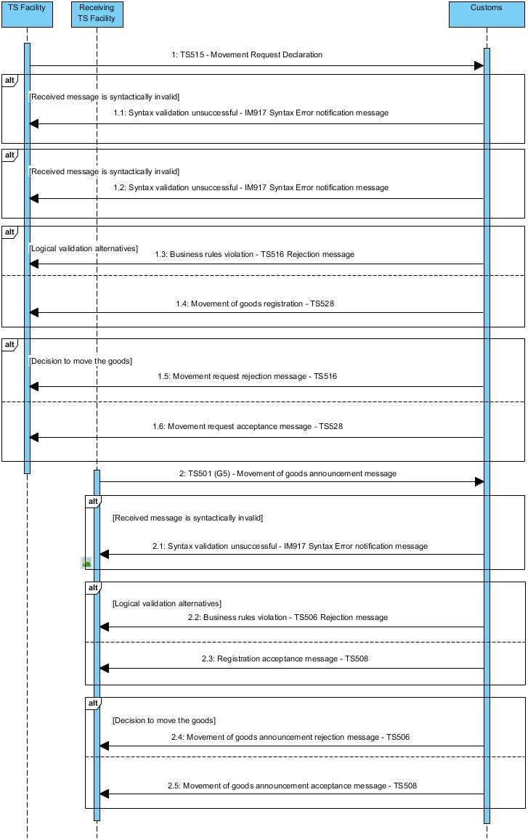

**Core Flow (Happy Path) – Movement Request is processed successfully**

1. AIS receives a TS515 message for a request to move goods from one TS facility to another
2. The TS515 message is syntactically valid
3. The TS515 message is logically valid (No business rules violation)
4. The movement request is accepted by a Customs Officer
5. AIS sends a TS528 request acceptance message to the Trader (including the MRN)
6. The receiving TS facility submits the TS501 (G5) message announcing the movement of the goods
7. The TS501 message is syntactically valid
8. The TS501 message is logically valid (No business rules violation)
9. The movement is accepted by a Customs Officer
10. AIS sends a TS508 G5 acceptance message to the Trader
11. The movement is completed

**Alt 1 - The movement request is syntactically invalid**

1. The process follows the core flow up to step 1
2. The TS515 message is syntactically invalid
3. AIS sends an IM917 Syntax Error Notification message to the Trader

**Alt 2 – The movement request is logically invalid**

1. The process follows the core flow up to step 2
2. The TS515 message has logical validation errors
3. AIS sends a TS516 rejection message to the Trader

**Alt 3 – The movement request is refused**

1. The process follows the core flow up to step 3
2. The movement request is refused by a Customs Officer
3. AIS sends a TS516 rejection message to the Trader

**Alt 4 - The movement notification is syntactically invalid**

1. The process follows the core flow up to step 6
2. The TS501 message is syntactically invalid
3. AIS sends an IM917 Syntax Error Notification message to the Trader

**Alt 5 – The movement notification is logically invalid**

1. The process follows the core flow up to step 7
2. The TS501 message has logical validation errors
3. AIS sends a TS506 rejection message to the Trader

**Alt 6 – The movement notification is rejected**

1. The process follows the core flow up to step 8
2. The TS501 message (movement notification) is refused by a Customs Officer
3. AIS sends a TS506 rejection message to the Trader
4. The movement is incomplete and the Trader shall submit a new movement notification

# Import

## Messages

See 2.5, 2.9, and 2.10

## Release for free circulation – Use Cases

### Standard Customs Declaration (H1, H5, H6, H7, I1)

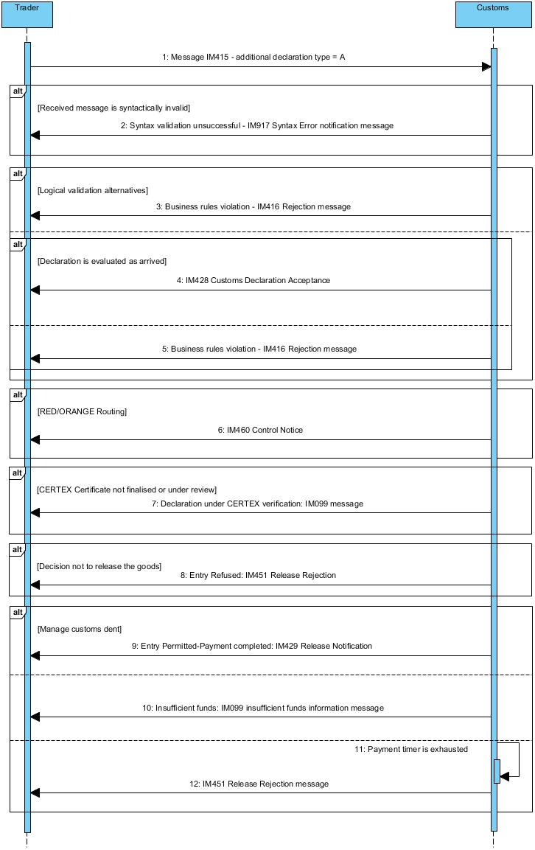

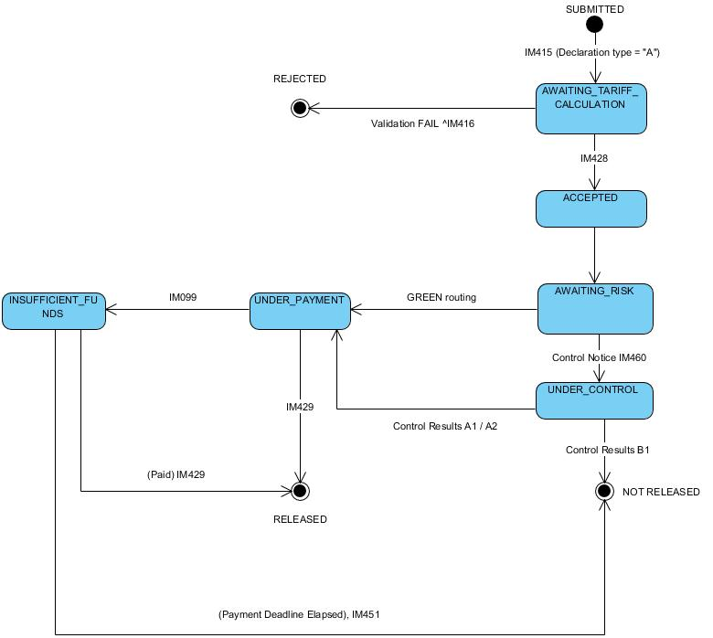

**Core Flow (Happy Path) - Standard Customs Declaration**

1. AIS receives an IM415 message (additional declaration type = A)
2. The message is syntactically valid
3. The message is logically valid (No business rules violation)
4. The declaration is evaluated as “arrived”
5. The declaration is accepted
6. AIS sends an IM428 acceptance message to the Trader
7. The declaration is Green routed

**Alt 1 - The declaration is syntactically invalid**

1. The process follows the Core Flow up to step 1
2. The IM415 message is syntactically invalid
3. AIS sends an IM917 Syntax Error message to the Trader

**Alt 2 - The declaration is logically invalid**

1. The process follows the Core Flow up to step 2
2. The IM415 message is logically invalid (Business rules violation)
3. AIS sends an IM416 rejection message to the Trader

**Alt 3 – The declaration is evaluated as “non-arrived”**

1. The process follows the Core Flow up to step 3
2. The declaration is evaluated as “non-arrived”
3. AIS sends an IM416 rejection message to the Trader

**Alt 4 – RED/ORANGE Routing**

1. The process follows the Core Flow up to step 6
2. The Declaration is Red/Orange routed
3. AIS sends an IM460 Control Notice message to the Trader

**Alt 5 – CERTEX Certificate not finalised** **or under review**

1. The process follows the core flow up to step 7
2. CERTEX reference is not finalised or under review
3. AIS sends an IM099 information message to the Trader (Declaration under CERTEX verification)

**Alt 6 - Decision to release the Goods - Entry Refused (Controls)**

1. The process follows the Alt 4 up to step 3
2. The Goods cannot be released
3. AIS sends an IM451 release rejection message to the Trader

**Alt 7 - Decision to release the Goods - Entry Permitted**

1. The process follows the Core Flow up to step 7 or positive control results
2. The payment process is completed successfully
3. The Goods can be released
4. AIS sends an IM429 release notification message to the Trader

**Alt 8 - Insufficient funds**

1. The process follows the Core Flow up to step 7
2. Customs debt is due, Trader’s account has insufficient funds
3. AIS sends an IM099 information message to the Trader (Insufficient funds)

**Alt 9 - Timer for payment expired**

1. The process follows the Alt 8 up to step 3
2. Trader has failed to fulfil their financial obligation to Customs within a specified time-limit
3. AIS sends an IM451 Release Rejection message to the Trader

### Pre-lodged Standard Customs Declaration (H1, H6, H7, I1)

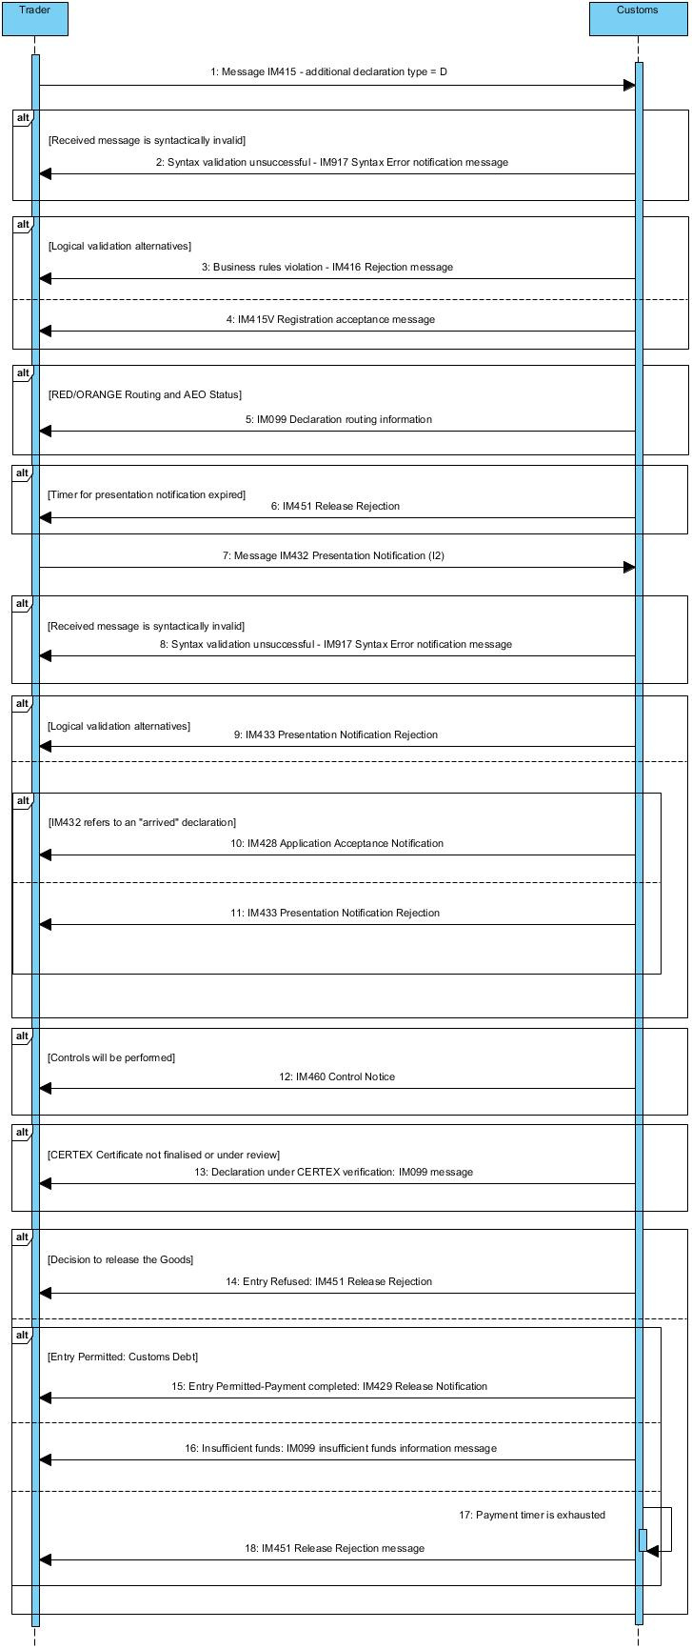

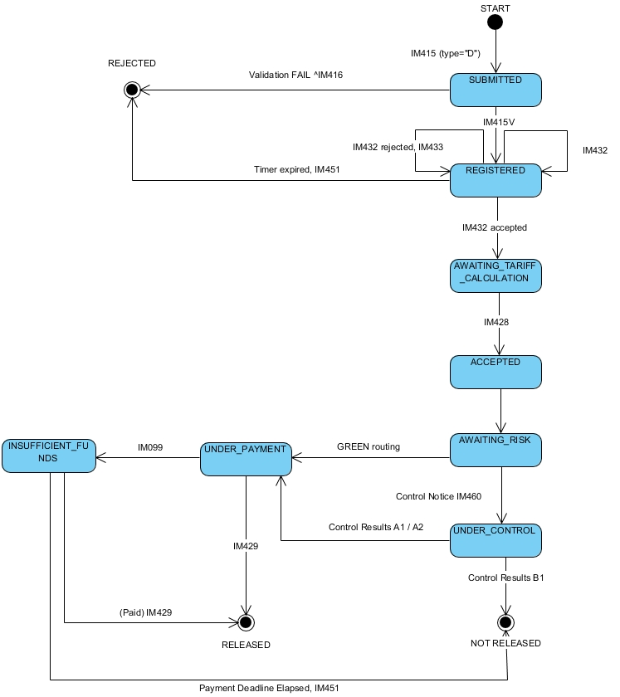

**Core Flow (Happy Path) - Pre-lodged Standard Customs Declaration**

1. AIS receives an IM415 message (additional declaration type = D)
2. The IM415 message is syntactically valid
3. The IM415 message is logically valid (No business rules violation)
4. AIS sends an IM415V Customs Declaration Acknowledgment message to the Trader
5. The declaration is Green routed
6. AIS receives the IM432 message
7. The IM432 message is syntactically valid
8. The IM432 message is logically valid (No business rules violation)
9. The IM432 message refers to an “arrived” declaration
10. AIS sends an IM428 acceptance message to the Trader

**Alt 1 - The declaration is syntactically invalid**

1. The process follows the Core Flow up to step 1
2. The IM415 message is syntactically invalid
3. AIS sends an IM917 Syntax Error Notification message to the Trader

**Alt 2 - The declaration is logically invalid**

1. The process follows the Core Flow up to step 2
2. The message is logically invalid (Business rules violation)
3. AIS sends an IM416 rejection message to the Trader

**Alt 3 – RED/ORANGE Routing**

1. The process follows the Core Flow up to step 4
2. The Declaration is Orange/Red routed
3. AIS sends an IM099 advanced routing information to the declaration Importer if AEO

**Alt 4 - Timer for presentation notification expired**

1. The process follows the Core Flow up to step 5
2. The timer for Presentation Notification expires
3. AIS sends an IM451 message to the Trader

**Alt 5 - The presentation notification is syntactically invalid**

1. The process follows the Core Flow up to step 6
2. The IM432 message is syntactically invalid
3. AIS sends an IM917 Syntax Error Notification message to the Trader

**Alt 6 – Logically invalid presentation notification**

1. The process follows the Core Flow up to step 7
2. The IM432 is logically invalid (Business rules violation)
3. AIS sends an IM433 rejection message to the Trader

**Alt 7 – IM432 refers to a “non-arrived” declaration**

1. The process follows the core flow up to step 8
2. The IM432message refers to a “non-arrived” declaration
3. AIS sends an IM433 rejection message to the Trader

**Alt 8 - Controls will be performed (Goods presented)**

1. The process follows the Alt 3 up to step 3
2. AIS sends an IM460 Control Notice message to the Trader

**Alt 9 – CERTEX Certificate not finalised** **or under review**

1. The process follows the core flow up to step 9
2. CERTEX reference is not finalised or under review
3. AIS sends an IM099 message (Declaration under CERTEX verification)

**Alt 10 - Decision to release the Goods - Entry Refused (Controls)**

1. The process follows the Alt 8 up to step 2
2. The Goods cannot be released
3. AIS sends an IM451 release rejection message to the Trader

**Alt 11 - Decision to release the Goods - Entry Permitted**

1. The process follows the Core Flow up to step 10 or positive control results
2. The payment process is completed successfully
3. The Goods can be released
4. AIS sends an IM429 release notification message to the Trader

**Alt 12 - Insufficient funds**

1. The process follows the Core Flow up to step 10
2. Customs debt is due, Trader’s account has insufficient funds
3. AIS sends an IM099 information message (insufficient funds)

**Alt 13 - Timer for payment expired**

1. The process follows the Alt 12 up to step 3
2. Trader has failed to fulfil their financial obligation to Customs within a specified time-limit
3. AIS sends an IM451 Release Rejection message

**Alt 14 – Tariff validation or calculation error after arrival and presentation**

1. The process follows the Core Flow up to step 9
2. An error is detected during the Tariff calculation.
3. Depending on the error, AIS sends an IM416 Customs Declaration Rejection or an IM451 Release Rejection message.

### Simplified Customs Declaration

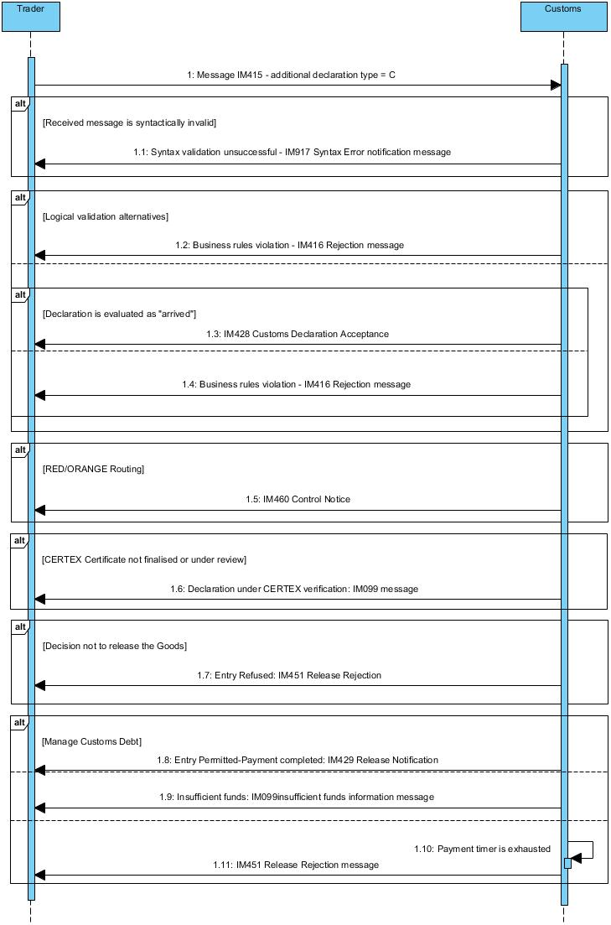

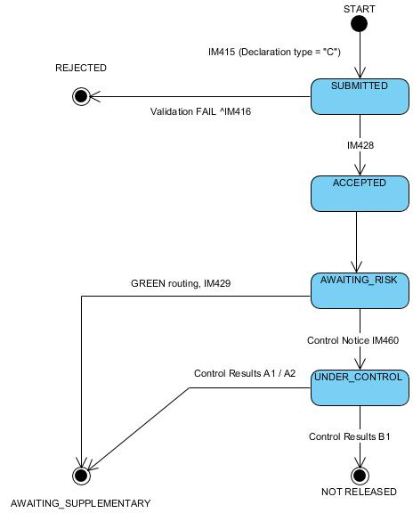

**Preconditions**

A simplified declaration (IM415) with additional declaration type B or C **WITHOUT**   supplementary waiver.

**Core Flow (Happy Path) - Simplified Customs Declaration**

1. AIS receives an IM415 message (additional declaration type = B or C)
2. The message is syntactically valid
3. The message is logically valid (No business rules violation)
4. Declaration is evaluated as “arrived”
5. AIS sends an IM428 acceptance message to the Trader
6. The declaration is Green routed

**Alt 1 - The declaration is syntactically invalid**

1. The process follows the Core Flow up to step 1
2. The IM415 message is syntactically invalid
3. AIS sends an IM917 Syntax Error Notification message to the Trader

**Alt 2 - The declaration is logically invalid**

1. The process follows the Core Flow up to step 2
2. The message is logically invalid (Business rules violation)
3. AIS sends an IM416 rejection message to the Trader

**Alt 3 – Declaration is evaluated as “non-arrived”**

1. The process follows the Core Flow up to step 3
2. Declaration is evaluated as “non-arrived”
3. AIS sends an IM416 rejection message to the Trader

**Alt 4 – RED/ORANGE Routing**

1. The process follows the Core Flow up to step 5
2. The Declaration is Orange/Red routed
3. AIS sends an IM460 Control Notice message to the Trader

**Alt 5 – CERTEX Certificate not finalised** **or under review**

1. The process follows the core flow up to step 6
2. CERTEX reference is not finalised or under review
3. AIS sends an IM099 notification message to the Trader (Declaration under CERTEX verification)

**Alt 6 - Decision to release the Goods - Entry Refused (Controls)**

1. The process follows the Alt 4 up to step 3
2. The Goods cannot be released
3. AIS sends an IM451 release rejection message to the Trader

**Alt 7 – Decision to release the Goods – Entry Permitted**

1. The process follows the Core Flow up to step 6 or positive control results
2. The Goods can be released
3. AIS sends an IM429 release permitted message to the Trader

### Simplified Customs Declaration with Supplementary Waiver



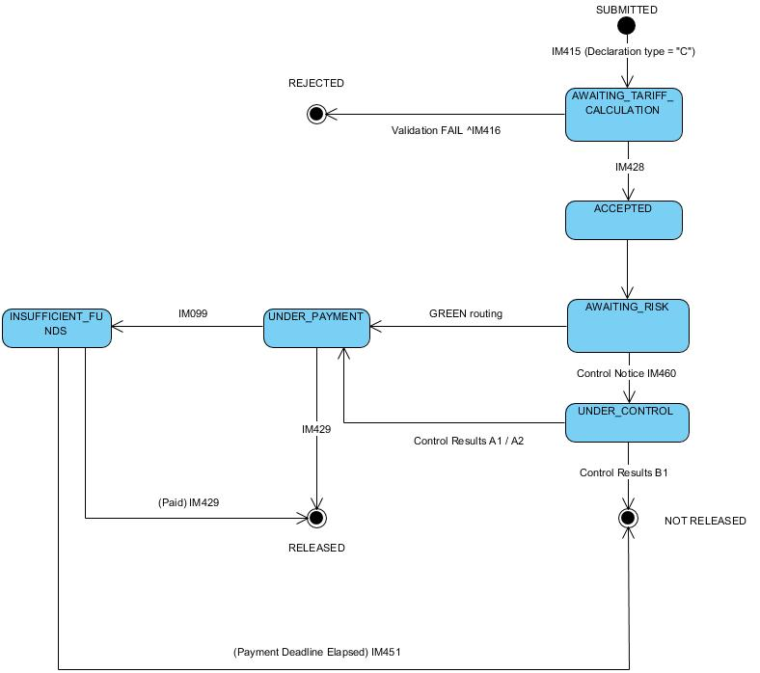

**Core Flow (Happy Path) - Simplified Customs Declaration with Supplementary Waiver**

1. AIS receives an IM415 message (additional declaration type = B or C)
2. The message is syntactically valid
3. The message is logically valid (No business rules violation)
4. The declaration is evaluated as arrived
5. The declaration is accepted
6. AIS sends an IM428 acceptance message to the Trader
7. The declaration is Green routed

**Alt 1 - The declaration is syntactically invalid**

1. The process follows the Core Flow up to step 1
2. The IM415 message is syntactically invalid
3. AIS sends an IM917 Syntax Error message to the Trader

**Alt 2 - The declaration is logically invalid**

1. The process follows the Core Flow up to step 2
2. The IM415 message is logically invalid (Business rules violation)
3. AIS sends an IM416 rejection message to the Trader

**Alt 3 – The declaration is evaluated as “non-arrived”**

1. The process follows the Core Flow up to step 3
2. The declaration is evaluated as “non-arrived”
3. AIS sends an IM416 rejection message to the Trader

**Alt 4 – RED/ORANGE Routing**

1. The process follows the Core Flow up to step 6
2. The Declaration is Red/Orange routed
3. AIS sends an IM460 Control Notice message to the Trader

**Alt 5 – CERTEX Certificate not finalised or under review**

1. The process follows the core flow up to step 7
2. CERTEX reference is not finalised or under review
3. AIS sends an IM099 information message to the Trader (Declaration under CERTEX verification)

**Alt 6 - Decision to release the Goods - Entry Refused (Controls)**

1. The process follows the Alt 4 up to step 3
2. The Goods cannot be released
3. AIS sends an IM451 release rejection message to the Trader

**Alt 7 - Decision to release the Goods - Entry Permitted**

1. The process follows the Core Flow up to step 7 or positive control results
2. The payment process is completed successfully
3. The Goods can be released
4. AIS sends an IM429 release notification message to the Trader

**Alt 8 - Insufficient funds**

1. The process follows the Core Flow up to step 7
2. Customs debt is due, Trader’s account has insufficient funds
3. AIS sends an IM099 information message to the Trader (Insufficient funds)

**Alt 9 - Timer for payment expired**

1. The process follows the Alt 8 up to step 3
2. Trader has failed to fulfil their financial obligation to Customs within a specified time-limit
3. AIS sends an IM451 Release Rejection message to the Trader

### Pre-Lodged Simplified Customs Declaration

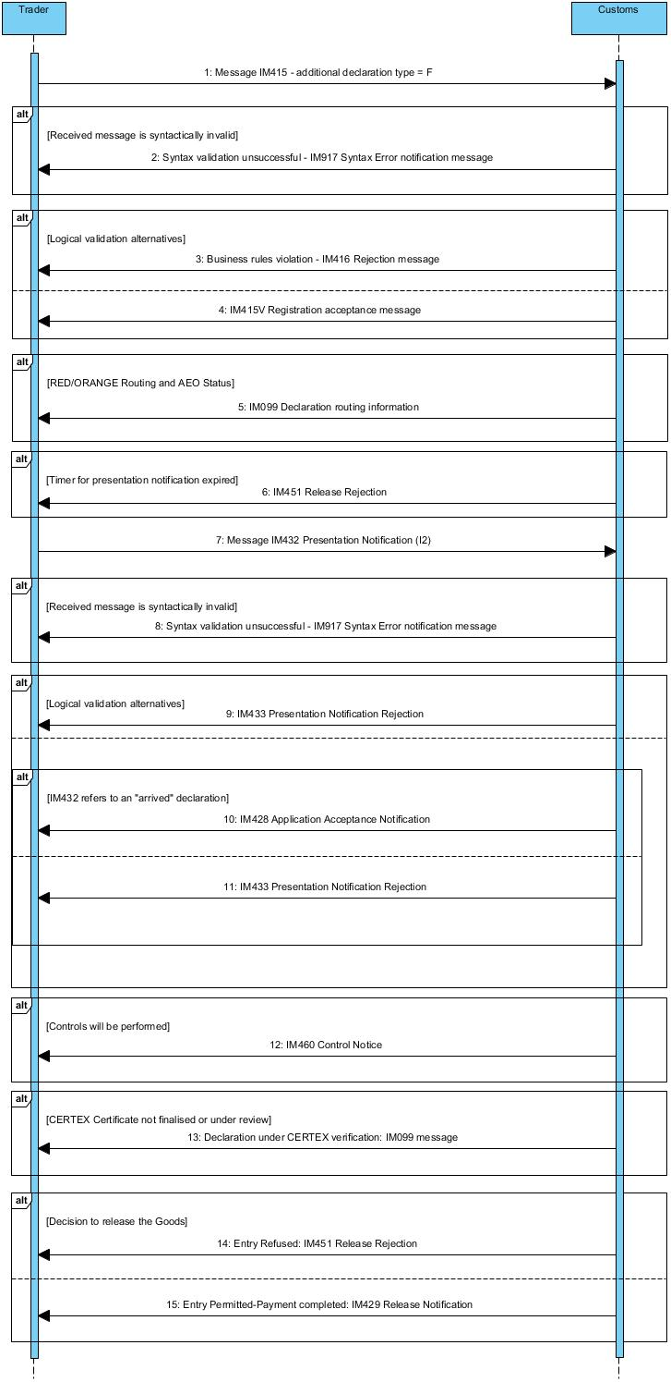

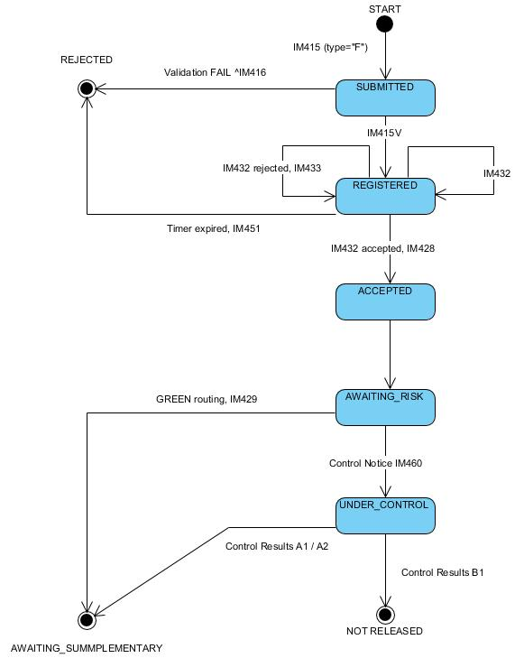

**Preconditions**

A simplified declaration (IM415) with additional declaration type E or F **WITHOUT** supplementary waiver

**Core Flow (Happy Path) - Pre-lodged Simplified Declaration**

1. AIS receives an IM415 message (additional declaration type = E or F)
2. The message is syntactically valid
3. The message is logically valid (No business rules violation)
4. AIS sends an IM415V Customs Declaration Acknowledgment (Registration) message to the Trader
5. The declaration is Green routed
6. AIS receives the IM432 message
7. The message is syntactically valid
8. The message is logically valid (No business rules violation)
9. IM432 refers to an “arrived” declaration
10. AIS sends an IM428 acceptance message to the Trader

**Alt 1 - The declaration is syntactically invalid**

1. The process follows the Core Flow up to step 1
2. The IM415 message is syntactically invalid
3. AIS sends an IM917 Syntax Error Notification message to the Trader

**Alt 2 - The declaration is logically invalid**

1. The process follows the Core Flow up to step 2
2. The message is logically invalid (Business rules violation)
3. AIS sends an IM416 rejection message to the Trader

**Alt 3 – RED/ORANGE Routing**

1. The process follows the Core Flow up to step 4
2. The Declaration is Orange/Red routed
3. AIS sends an IM099 declaration routing information to the declaration Importer if AEO

**Alt 4 - Timer for presentation notification expired**

1. The process follows the Core Flow up to step 5
2. The timer for Presentation Notification expires
3. AIS sends an IM451 message to the Trader

**Alt 5 - The presentation notification is syntactically invalid**

1. The process follows the Core Flow up to step 6
2. The IM432 message is syntactically invalid
3. AIS sends an IM917 Syntax Error Notification message to the Trader

**Alt 6 - Invalid presentation notification**

1. The process follows the Core Flow up to step 7
2. The message is logically invalid (Business rules violation)
3. AIS sends an IM433 rejection message to the Trader

**Alt 7 – IM432 refers to a “non-arrived” declaration**

1. The process follows the core flow up to step 8
2. IM432 refers to a “non-arrived” declaration
3. AIS sends an IM433 rejection message to the Trader

**Alt 8 - Controls will be performed**

1. The process follows the Alt 3 up to step 3
2. AIS sends an IM460 Control Notice message to the Trader

**Alt 9 – CERTEX reference not finalised or under review**

1. The process follows the core flow up to step 10
2. CERTEX reference is not finalised or under review
3. AIS sends IM099 “Declaration under CERTEX verification” message to the Trader

**Alt 10 - Decision to release the Goods - Entry Refused (Controls)**

1. The process follows the Alt 8 up to step 2
2. The Goods cannot be released
3. AIS sends an IM451 release rejection message to the Trader

**Alt 11 - Decision to release the Goods - Entry Permitted**

1. The process follows the Core Flow up to step 9 or positive control results
2. The Goods can be released
3. AIS sends an IM429 release notification message to the Trader

### Pre-Lodged Simplified Customs Declaration with supplementary waiver

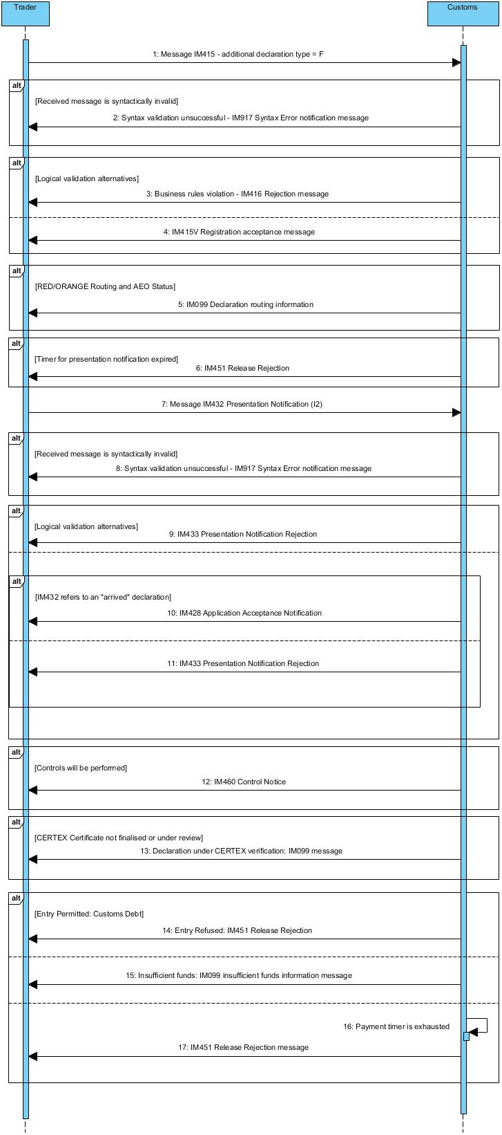

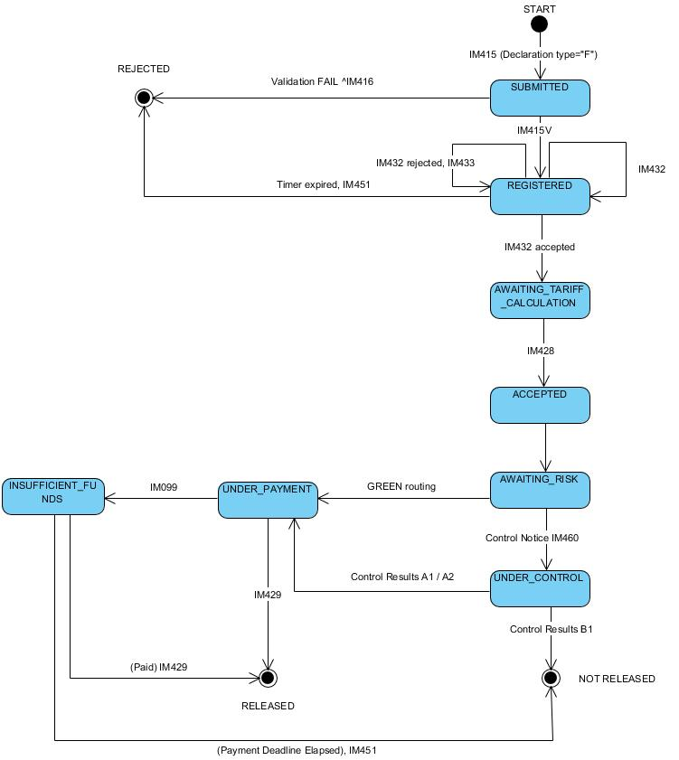

**Core Flow (Happy Path) - Pre-lodged Simplified Customs Declaration with Supplementary waiver**

1. AIS receives an IM415 message (additional declaration type = E or F)
2. The IM415 message is syntactically valid
3. The IM415 message is logically valid (No business rules violation)
4. AIS sends an IM415V Customs Declaration Acknowledgment message to the Trader
5. The declaration is Green routed
6. AIS receives the IM432 message
7. The IM432 message is syntactically valid
8. The IM432 message is logically valid (No business rules violation)
9. The IM432 message refers to an “arrived” declaration
10. AIS sends an IM428 acceptance message to the Trader

**Alt 1 - The declaration is syntactically invalid**

1. The process follows the Core Flow up to step 1
2. The IM415 message is syntactically invalid
3. AIS sends an IM917 Syntax Error Notification message to the Trader

**Alt 2 - The declaration is logically invalid**

1. The process follows the Core Flow up to step 2
2. The message is logically invalid (Business rules violation)
3. AIS sends an IM416 rejection message to the Trader

**Alt 3 – RED/ORANGE Routing**

1. The process follows the Core Flow up to step 4
2. The Declaration is Orange/Red routed
3. AIS sends an IM099 advanced routing information to the declaration Importer if AEO

**Alt 4 - Timer for presentation notification expired**

1. The process follows the Core Flow up to step 5
2. The timer for Presentation Notification expires
3. AIS sends an IM451 message to the Trader

**Alt 5 - The presentation notification is syntactically invalid**

1. The process follows the Core Flow up to step 6
2. The IM432 message is syntactically invalid
3. AIS sends an IM917 Syntax Error Notification message to the Trader

**Alt 6 – Logically invalid presentation notification**

1. The process follows the Core Flow up to step 7
2. The IM432 is logically invalid (Business rules violation)
3. AIS sends an IM433 rejection message to the Trader

**Alt 7 – IM432 refers to a “non-arrived” declaration**

1. The process follows the core flow up to step 8
2. The IM432message refers to a “non-arrived” declaration
3. AIS sends an IM433 rejection message to the Trader

**Alt 8 - Controls will be performed (Goods presented)**

1. The process follows the Alt 3 up to step 3
2. AIS sends an IM460 Control Notice message to the Trader

**Alt 9 – CERTEX Certificate not finalised or under review**

1. The process follows the core flow up to step 9
2. CERTEX reference is not finalised or under review
3. AIS sends IM099 “Declaration under CERTEX verification” message

**Alt 10 - Decision to release the Goods - Entry Refused (Controls)**

1. The process follows the Alt 8 up to step 2
2. The Goods cannot be released
3. AIS sends an IM451 release rejection message to the Trader

**Alt 11 - Decision to release the Goods - Entry Permitted**

1. The process follows the Core Flow up to step 10 or positive control results
2. The payment process is completed successfully
3. The Goods can be released
4. AIS sends an IM429 release notification message to the Trader

**Alt 12 - Insufficient funds**

1. The process follows the Core Flow up to step 10
2. Customs debt is due, Trader’s account has insufficient funds
3. AIS sends an IM099 “insufficient funds” information message

**Alt 13 - Timer for payment expired**

1. The process follows the Alt 12 up to step 3
2. Trader has failed to fulfil their financial obligation to Customs within a specified time-limit
3. AIS sends an IM451 Release Rejection message

### Supplementary Declaration

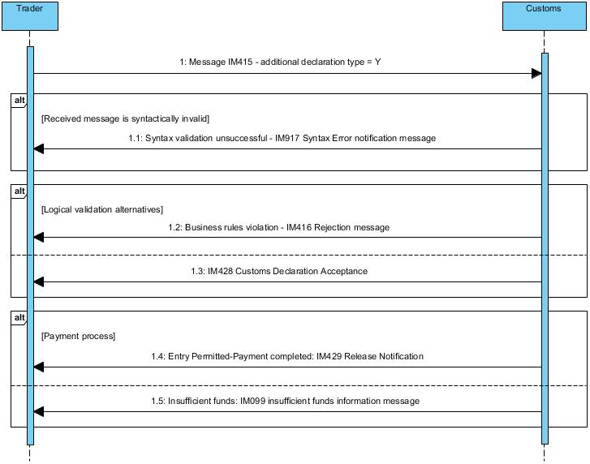

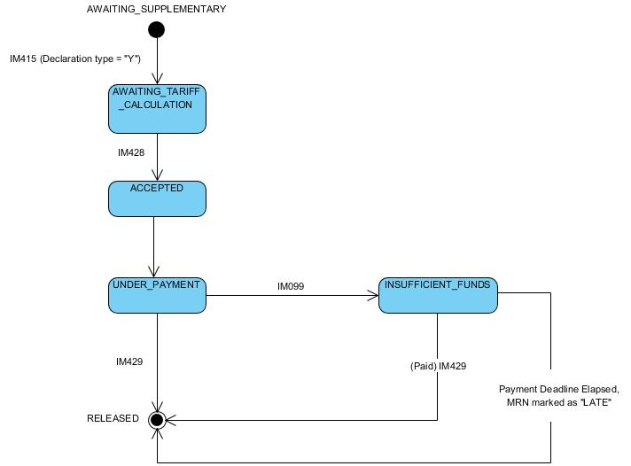

**Preconditions**

A simplified declaration (IM415) with additional declaration type C or F (B or E) **WITHOUT** supplementary waiver.

**Core Flow (Happy Path) - Supplementary Declaration**

1. AIS receives an IM415 message - Additional declaration type = Y (for C or F) or Additional declaration type = X (for B or E)
2. The message is syntactically valid
3. The message is logically valid (No business rules violation)
4. AIS sends an IM428 acceptance message to the Trader
5. Payment process completed successfully
6. AIS sends an IM429 Release Notification message to the Trader

**Alt 1 - The declaration is syntactically invalid**

1. The process follows the Core Flow up to step 1
2. The IM415 message is syntactically invalid
3. AIS sends an IM917 Syntax Error Notification message to the Trader

**Alt 2 - The declaration is logically invalid**

1. The process follows the Core Flow up to step 2
2. The message is logically invalid (Business rules violation)
3. AIS sends an IM416 rejection message to the Trader

**Alt 3 - Insufficient funds**

1. The process follows the Core Flow up to step 4
2. Customs debt is due, Trader’s account has insufficient funds
3. AIS sends an IM099 information message to the Trader (Insufficient funds)

### EIDR with PN and Supplementary Declaration (Type Z)

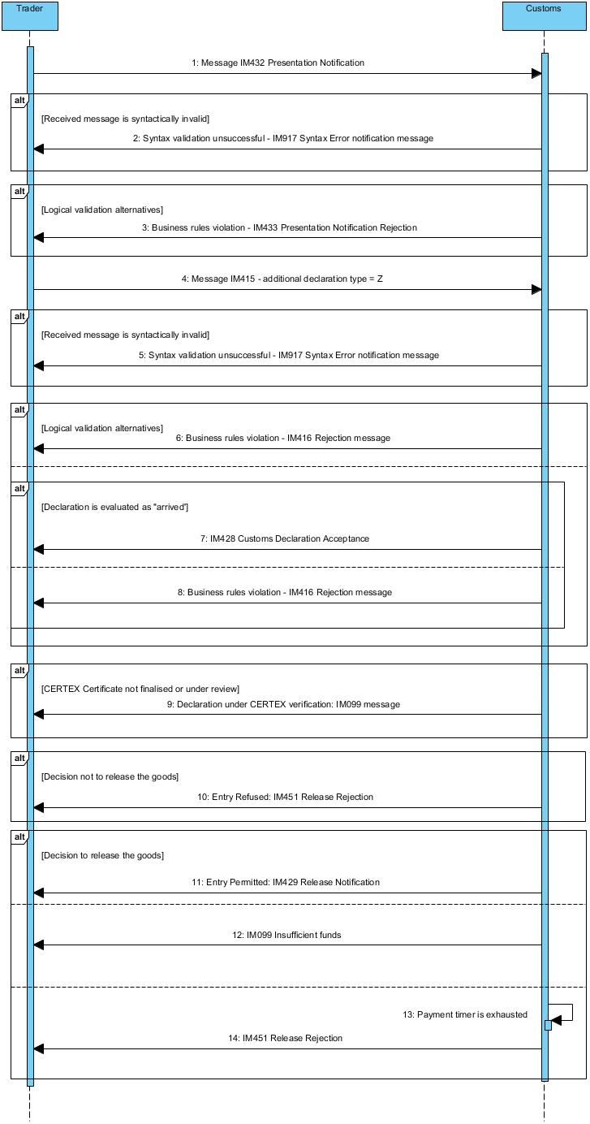

**Core Flow (Happy Path) - EIDR with Presentation notification**

1. AIS receives IM432 Presentation Notification
2. IM432 is syntactically valid
3. IM432 is logically valid
4. AIS receives an IM415 Supplementary Customs Declaration - Additional declaration type = Z message
5. The message is syntactically valid
6. The message is logically valid (No business rules violation)
7. The declaration is evaluated as “arrived”
8. AIS sends an IM428 acceptance message to the Trader
9. The payment process is completed successfully
10. AIS sends an IM429 release message to the Trader

**Alt 1 - IM432 is syntactically invalid**

1. The process follows the core flow up to step 1
2. IM432 is syntactically invalid
3. AIS sends an IM917 Syntax Error Notification message to the Trader

**Alt 2 – IM432 is logically invalid**

1. The process follows the core flow up to step 2
2. IM432 is logically invalid (Business rules violation)
3. AIS sends an IM433 rejection message to the Trader

**Alt 3 - The declaration is syntactically invalid**

1. The process follows the core flow up to step 4
2. The message is syntactically invalid
3. AIS sends an IM917 Syntax Error Notification message to the Trader

**Alt 4 - The declaration is logically invalid**

1. The process follows the core flow up to step 5
2. The message is logically invalid (Business rules violation)
3. AIS sends an IM416 rejection message to the Trader

**Alt 5 – The declaration is evaluated as “non-arrived”**

1. The process follows the core flow up to step 6
2. The declaration is evaluated as “non-arrived”
3. AIS sends an IM416 rejection message to the Trader

**Alt 6 – CERTEX Certificate not finalised or under review**

1. The process follows the core flow up to step 7
2. CERTEX Certificate is not finalised or under review
3. AIS sends an IM099 message to the Trader (Declaration under CERTEX verification)

**Alt 7 - The Supplementary declaration is in ‘Insufficient funds’**

1. The process follows the core flow up to step 7
2. AIS sends an IM099 information message to the Trader (Insufficient funds)

**Alt 8 – Payment timer is exhausted**

1. The process follows the Alt 5 up to step 2
2. Payment timer is exhausted
3. AIS sends IM451 Release rejection message to the Trader

### EIDR with PN waiver and Supplementary Declaration (Type Z)

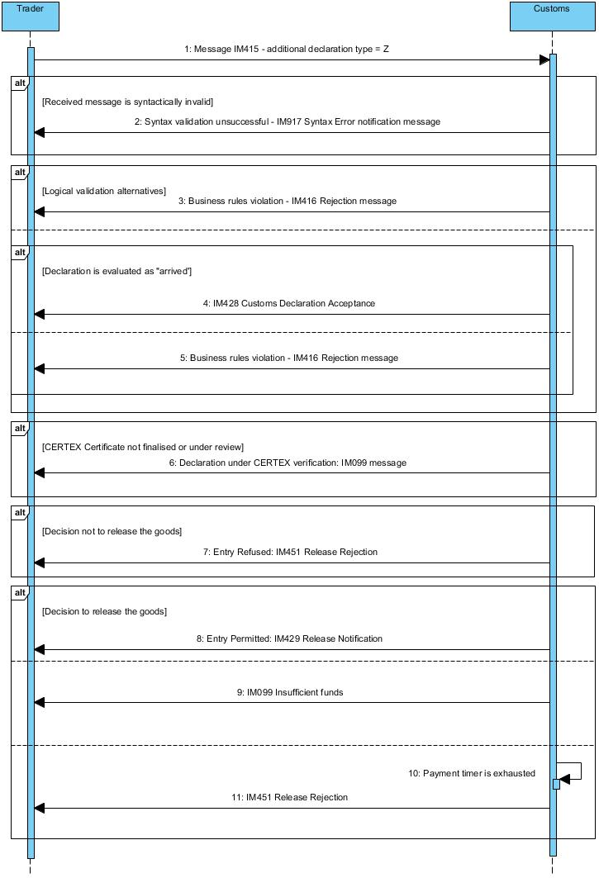

**Core Flow (Happy Path) - EIDR - Presentation notification waiver**

1. AIS receives an IM415 Supplementary Customs Declaration - Additional declaration type = Z message
2. The message is syntactically valid
3. The message is logically valid (No business rules violation)
4. The declaration is evaluated as “arrived”
5. AIS sends an IM428 acceptance message to the Trader
6. The payment process is completed successfully
7. AIS sends an IM429 release message to the Trader

**Alt 1 - The declaration is syntactically invalid**

1. The process follows the core flow up to step 1
2. The message is syntactically invalid
3. AIS sends an IM917 Syntax Error Notification message to the Trader

**Alt 2 - The declaration is logically invalid**

1. The process follows the core flow up to step 2
2. The message is logically invalid (Business rules violation)
3. AIS sends an IM416 rejection message to the Trader

**Alt 3 – The declaration is evaluated as “non-arrived”**

1. The process follows the core flow up to step 3
2. The declaration is evaluated as “non-arrived”
3. AIS sends an IM416 rejection message to the Trader

**Alt 4 – CERTEX Certificate not finalised or under review**

1. The process follows the core flow up to step 5
2. CERTEX Certificate is not finalised or under review
3. AIS sends IM099 “Declaration under CERTEX verification” message to the Trader

**Alt 5 - The Supplementary declaration is in ‘Insufficient funds’**

1. The process follows the core flow up to step 5
2. AIS sends an IM099 “insufficient funds” information message to the Trader

**Alt 6 – Payment timer is exhausted**

1. The process follows the Alt 5 up to step 2
2. Payment timer is exhausted
3. AIS sends IM451 Release rejection message to the Trader

### Amendment of the Customs Declaration

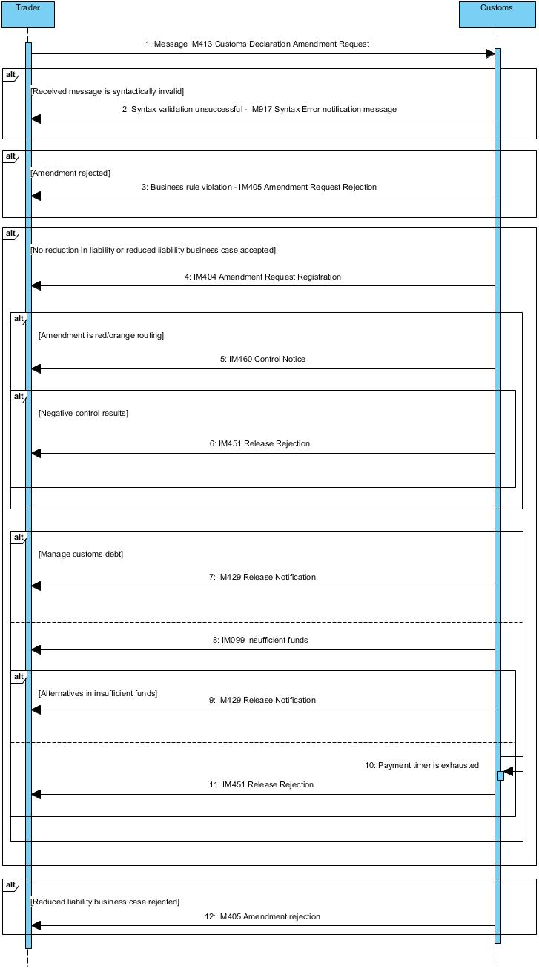

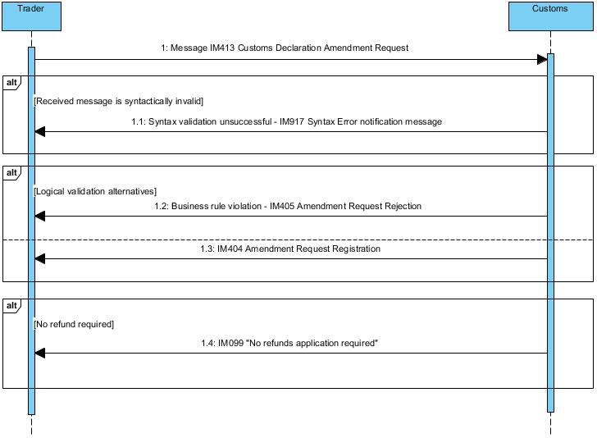

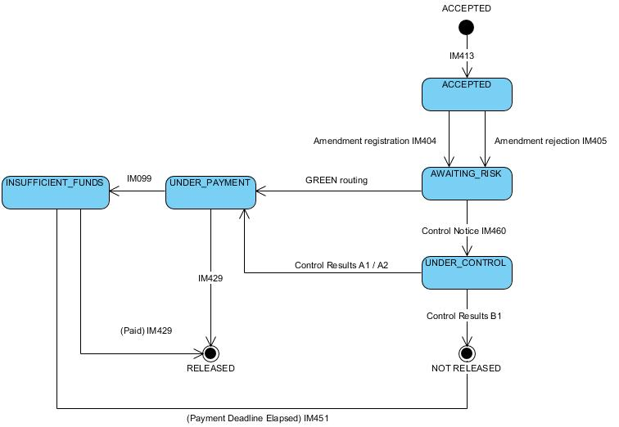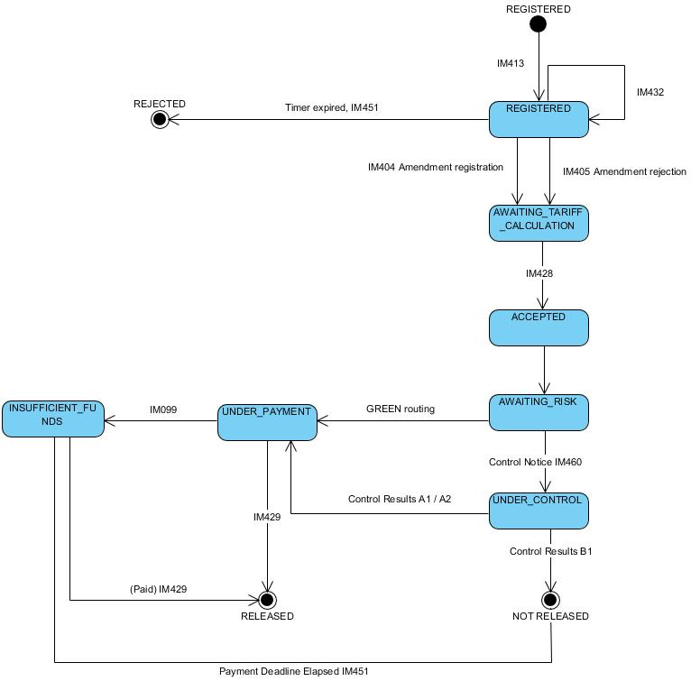

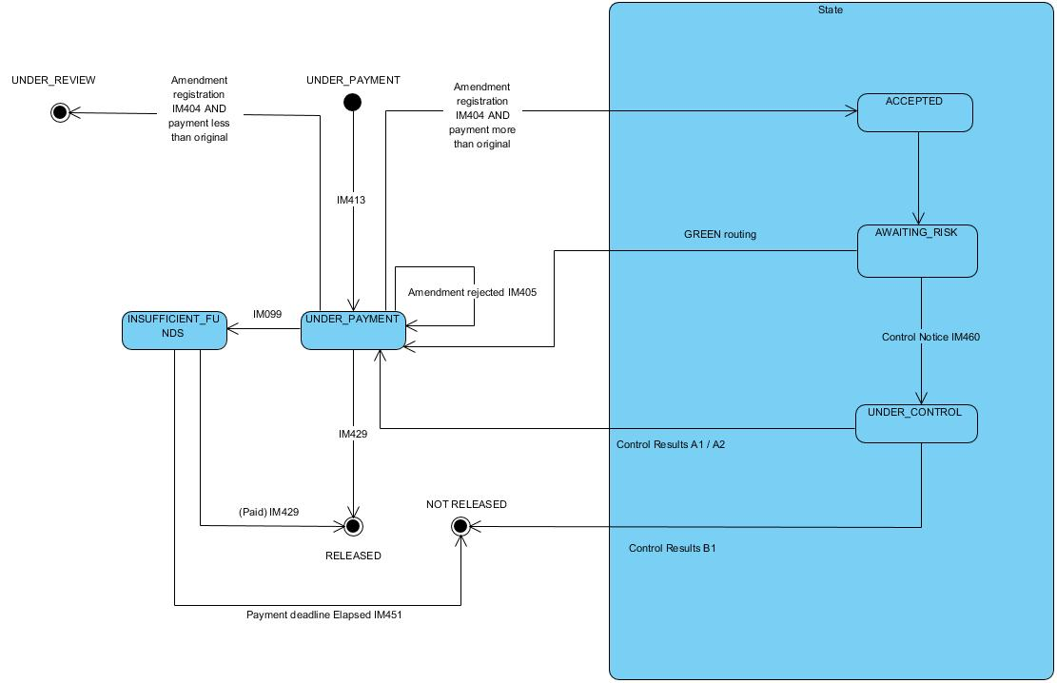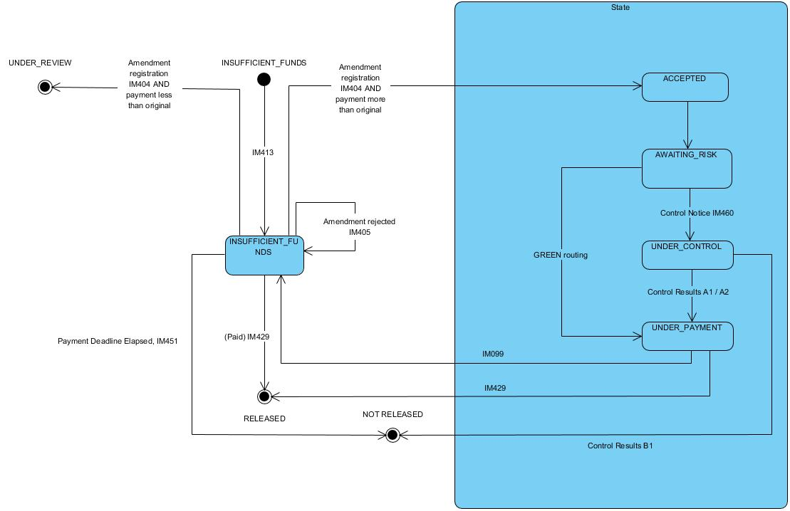

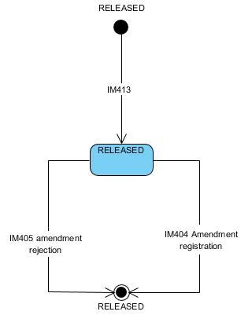

**Core Flow (Happy Path) - Amendment of the Customs Declaration in [INSUFFICIENT_FUNDS] status**

1. AIS receives an IM413 message
2. The message is syntactically valid
3. The message is logically valid (No business rules violation)
4. No reduction in liability or reduced liability business case accepted
5. AIS sends an IM404 acceptance message to the Trader
6. The declaration is Green routed
7. The payment process is completed successfully
8. The Goods can be released
9. AIS sends an IM429 release notification message to the Trader

**Alt 1 - The request is syntactically invalid**

1. Process follows the Core Flow up to step 1
2. The IM413 message is syntactically invalid
3. AIS sends an IM917 Syntax Error Notification message to the Trader

**Alt 2 - The request is logically invalid**

1. Process follows the Core Flow up to step 2
2. The IM413 message is logically invalid (Business rules violation)
3. AIS sends an IM405 Amendment Request Rejection message to the Trader

**Alt 3 – Insufficient funds**

1. Process follows the Core Flow up to step 6
2. No funds available
3. AIS sends IM099 insufficient funds to the Trader

**Alt 4 – Payment timer expired**

1. Process follows the Alt 3 up to step 3
2. Payment timer is exhausted
3. AIS sends IM451 release rejection message to the Trader

**Alt 5 – RED/ORANGE Routing and positive results**

1. Process follows the Core Flow up to step 5
2. The Declaration is Orange/Red routed
3. AIS sends an IM460 Control Notice message to the Trader
4. The payment process is completed successfully
5. The Goods can be released
6. AIS sends an IM429 release notification message to the Trader

**Alt 6 -** **RED/ORANGE Routing and positive results (insufficient funds)**

1. Process follows the Alt 5 up to step 4
2. No funds available
3. AIS sends IM099 insufficient funds to the Trader
4. If payment timer expires, process resumes from Alt 4 step 2

**Alt 7 - RED/ORANGE Routing and negative results**

1. Process follows the Alt 5 up to step 4
2. Control case is closed with negative results
3. AIS sends an IM451 release rejection message to the Trader

**Alt 8 – Reduced liability (Amendment request rejected after review)**

1. The process follows the core flow up to step 3
2. AIS sends IM405 Amendment rejection message to the Trader

**Declaration Amendment in [RELEASED] status**

**Core Flow (Happy Path) - Amendment of the Customs Declaration (Post release)**

1. AIS receives an IM413 message
2. The message is syntactically valid
3. The message is logically valid (No business rules violation)
4. AIS sends an IM404 acceptance message to the Trader
5. AIS sends IM099 “No refund application required”

**Alt 1 - The request is syntactically invalid**

1. Process follows the Core Flow up to step 1
2. The IM413 message is syntactically invalid
3. AIS sends an IM917 Syntax Error Notification message to the Trader

**Alt 2 - The request is logically invalid**

1. Process follows the Core Flow up to step 2
2. The IM413 message is logically invalid (Business rules violation)
3. AIS sends an IM405 Amendment Request Rejection message to the Trader

### Invalidation of the Customs Declaration

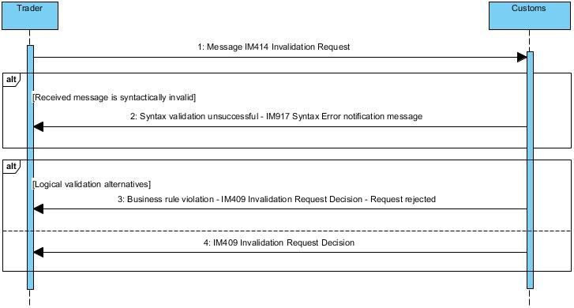

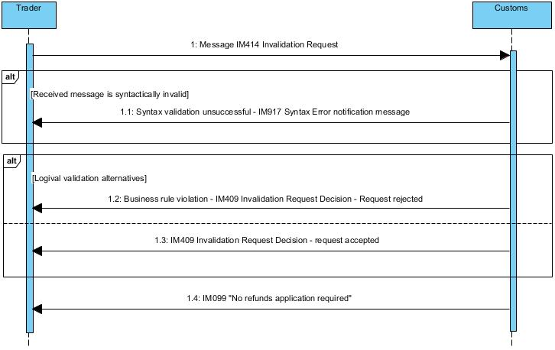

Figure 1: Declaration Invalidation Post release

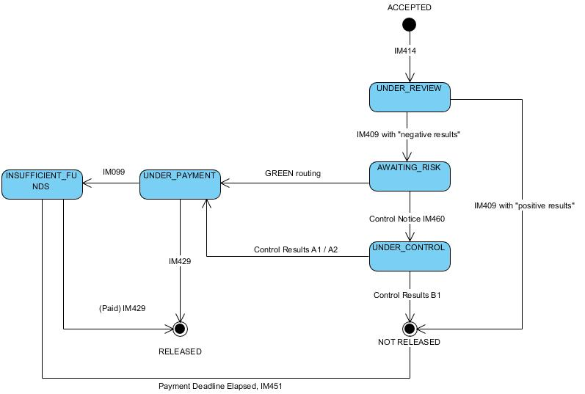

Figure 2: Declaration Invalidation in [ACCEPTED] status

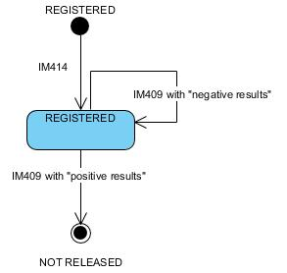

Figure 3: Declaration Invalidation in [REGISTERED] status

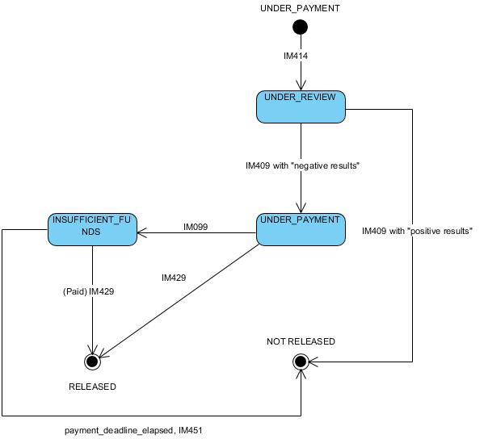

Figure 4: Declaration Invalidation in [UNDER_PAYMENT] status

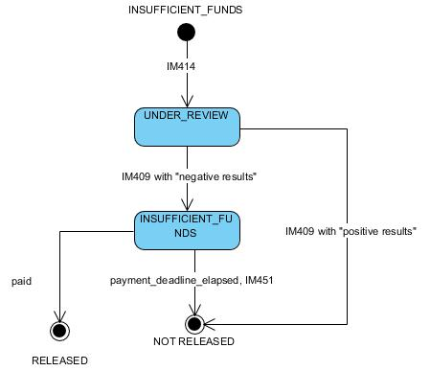

Figure 5: Declaration Invalidation in [INSUFFICIENT_FUNDS] status

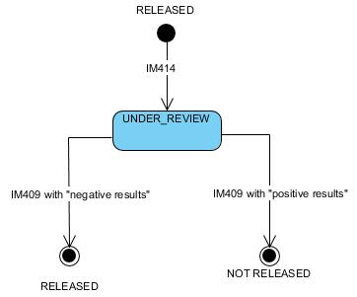

Figure 6: Declaration Invalidation in [RELEASED] status

**Core Flow – Invalidation of the Customs Declaration**

1. AIS receives an IM414 message
2. The message is syntactically valid
3. The message is logically valid (No business rules violation)
4. The invalidation is accepted
5. AIS sends an IM409 Invalidation Request Decision - request acceptance message to the Trader

**Alt 1 - The request is syntactically invalid**

1. Process follows the Core Flow up to step 1
2. The IM414 message is syntactically invalid
3. AIS sends an IM917 Syntax Error Notification message to the Trader

**Alt 2 - The request is logically invalid**

1. Process follows the Core Flow up to step 2
2. The IM414 message is logically invalid (Business rules violation)
3. The invalidation is rejected
4. AIS sends an IM409 Invalidation Request Decision - request rejected message to the Trader

**Core Flow – Invalidation of the Customs Declaration (Post release)**

1. AIS receives an IM414 message
2. The message is syntactically valid
3. The message is logically valid (No business rules violation)
4. The invalidation is accepted
5. AIS sends an IM409 Invalidation Request Decision - request acceptance message to the Trader
6. No refund is required
7. AIS sends IM099 “No refund application required” to the Trader

**Alt 1 - The request is syntactically invalid**

1. Process follows the Core Flow up to step 1
2. The IM414 message is syntactically invalid
3. AIS sends an IM917 Syntax Error Notification message to the Trader

**Alt 2 - The request is logically invalid**

1. Process follows the Core Flow up to step 2
2. The IM414 message is logically invalid (Business rules violation)
3. The invalidation is rejected
4. AIS sends an IM409 Invalidation Request Decision - request rejected message to the Trader

## Special Procedures – Use Cases

### Prior Import for Outward Processing

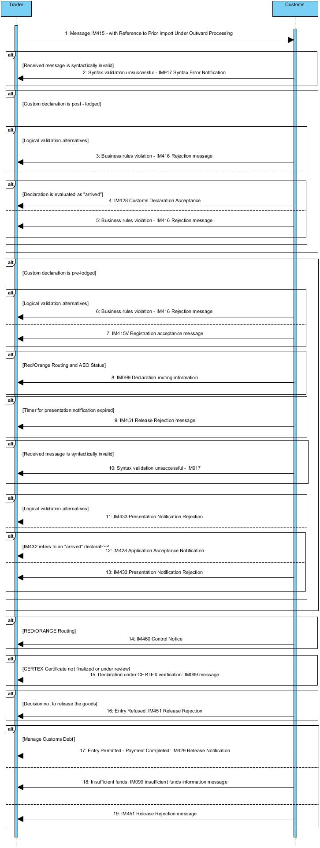

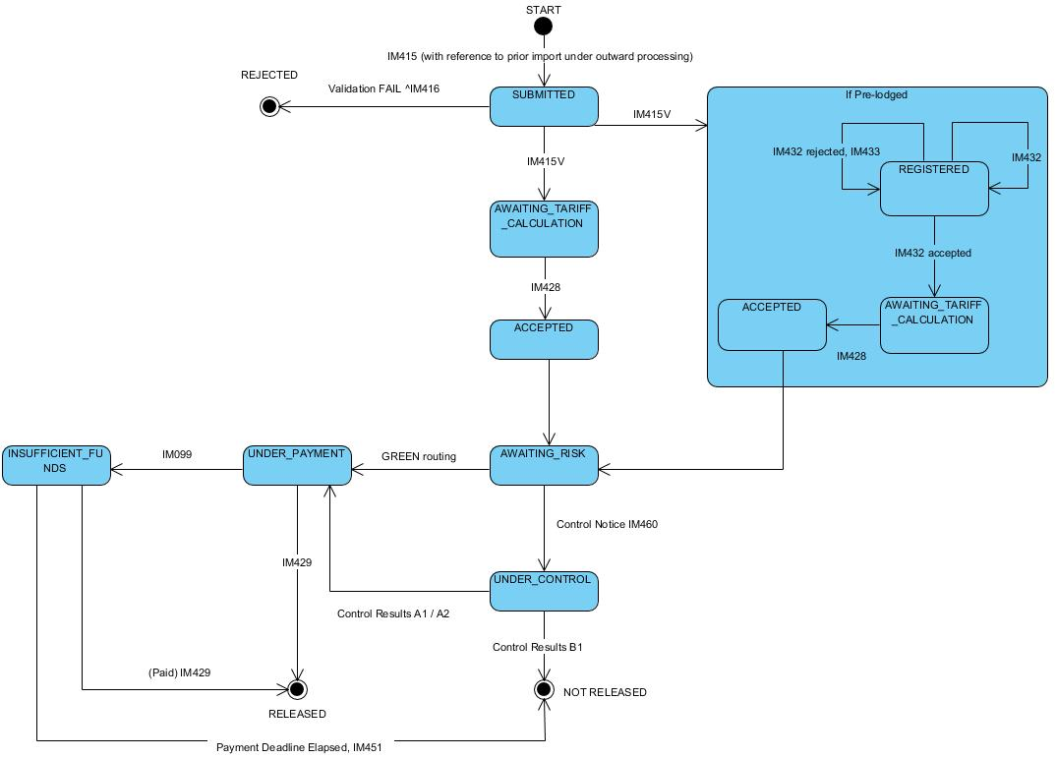

**Core Flow (Happy Path) - Prior Import for Outward Processing**

1. AIS receives an IM415 message - with Reference to Prior Import Under Outward Processing
2. The message is syntactically valid
3. The message is logically valid (No business rules violation)
4. Declaration is evaluated as “arrived”
5. AIS sends an IM428 acceptance message to the Trader
6. The declaration is Green routed or positive control result (after Alt 9 step 3)
7. Payment process completed successfully
8. AIS sends an IM429 Release Notification message to the Trader

**Alt 1 - The declaration is syntactically invalid**

1. The process follows the core flow up to step 1
2. The IM415 message is syntactically invalid
3. AIS sends an IM917 Syntax Error Notification message to the Trader

**Alt 2 - The declaration is logically invalid**

1. The process follows the core flow up to step 2
2. The IM415 message is logically invalid (Business rules violation)
3. AIS sends an IM416 rejection message to the Trader

**Alt 3 - Customs declaration is pre-lodged**

1. The process follows the core flow up to step 3
2. AIS sends an IM415V Customs Declaration Acknowledgment message to the Trader
3. AIS receive IM432 presentation notification
4. IM432 is syntactically valid
5. IM432 is logically valid
6. The IM432 message refers to an “arrived” declaration
7. Process continues from step 5 of the core flow

**Alt 4 - Red / orange routing and AEO status**

1. The process follows the Alt 3 up to step 2
2. Routing is red / orange and AEO status
3. IM099 with declaration routing information is sent to the Trader

**Alt 5 – Timer for presentation notification is expired**

1. The process follows the Alt 3 up to step 2
2. The timer for presentation notification is expired
3. IM451 Release rejection is sent to the Trader

**Alt 6 - The presentation notification is syntactically invalid**

1. The process follows the Alt 3 up to step 3
2. The IM432 message is syntactically invalid
3. AIS sends an IM917 Syntax Error Notification message to the Trader

**Alt 7 – The presentation notification is logically invalid**

1. The process follows the Alt 3 up to step 4
2. The message is logically invalid (Business rules violation)
3. AIS sends an IM433 rejection message to the Trader

**Alt 8 - IM432 refers to a “non-arrived” declaration**

1. The process follows the Alt 3 up to step 5
2. IM432 refers to a “non-arrived” declaration
3. AIS sends an IM433 rejection message to the Trader

**Alt 9 – RED/ORANGE Routing**

1. The process follows the core flow up to step 5
2. The Declaration is Red/Orange routed
3. AIS sends an IM460 Control Notice message to the Trader

**Alt 10 – CERTEX Certificate not finalised** **or under review**

1. The process follows the core flow up to step 6
2. CERTEX certificate is not finalised
3. AIS sends IM099 – “Declaration under CERTEX verification” message to the Trader

**Alt 11 - Decision to release the Goods - Entry Refused**

1. The process follows the Alt 9 to step 3
2. The Goods cannot be released
3. AIS sends an IM451 release rejection message to the Trader

**Alt 11 - Insufficient funds**

1. The process follows the core flow up to step 6
2. Customs debt is due, Trader’s account has insufficient funds
3. AIS sends an IM099 “insufficient funds” information message to the Trader

**Alt 12 - Timer for payment expired**

1. The process follows the Alt 11 up to step 3
2. Trader has failed to fulfil their financial obligation to within a specified time-limit
3. AIS sends an IM451 Release Rejection message to the Trader

### Placement - Standard Declaration for SP (H1, H2, H3, H4, I1)

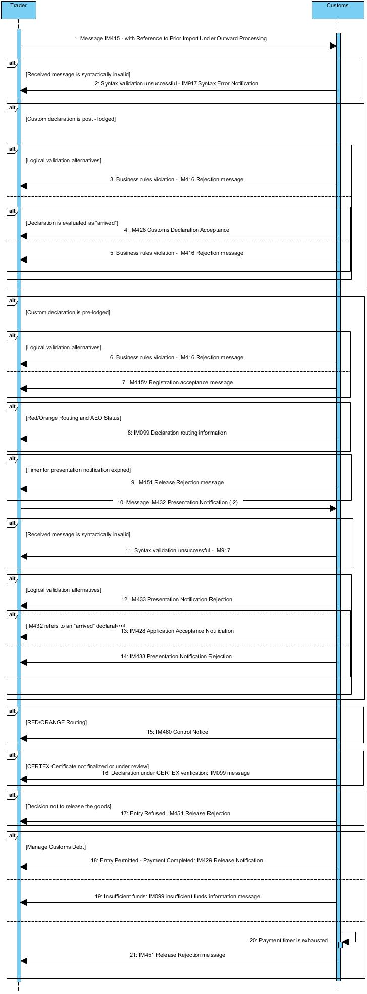

**Note:** This sequence also applies to declaration constitutes application (EUCDM 8f) cases.

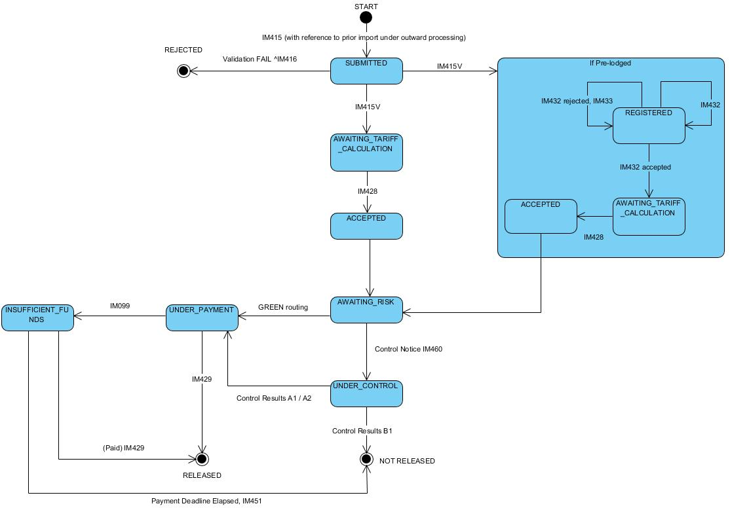

**Core Flow (Happy Path) - Placement - Standard Declaration for Special Procedure (H1, H2, H3, H4, I1)**

1. AIS receives an IM415 message – Standard Customs Declaration for Special Procedures
2. The message is syntactically valid
3. The message is logically valid (No business rules violation)
4. Declaration is evaluated as “arrived”
5. AIS sends an IM428 acceptance message to the Trader
6. The declaration is Green routed or positive control results (after Alt 9 step 3)
7. Payment process completed successfully
8. AIS sends an IM429 Release Notification message to the Trader

**Alt 1 - The declaration is syntactically invalid**

1. The process follows the core flow up to step 1
2. The IM415 message is syntactically invalid
3. AIS sends an IM917 Syntax Error Notification message to the Trader

**Alt 2 - The declaration is logically invalid**

1. The process follows the core flow up to step 2
2. The IM415 message is logically invalid (Business rules violation)
3. AIS sends an IM416 rejection message to the Trader

**Alt 3 - Customs declaration is pre-lodged**

1. The process follows the core flow up to step 3
2. AIS sends an IM415V Customs Declaration Acknowledgment message to the Trader
3. AIS receive IM432 presentation notification
4. IM432 is syntactically valid
5. IM432 is logically valid
6. The IM432 message refers to an “arrived” declaration
7. Process continues from step 5 of the core flow

**Alt 4 - Red / orange routing and AEO status**

1. The process follows the Alt 3 up to step 2
2. Routing is red / orange and declarant has AEO status
3. IM099 with declaration routing information is sent to the Trader

**Alt 5 – Timer for presentation notification is expired**

1. The process follows the Alt 3 up to step 2
2. The timer for presentation notification is expired
3. IM451 Release rejection is sent to the Trader

**Alt 6 - The presentation notification is syntactically invalid**

1. The process follows the Alt 3 up to step 3
2. The IM432 message is syntactically invalid
3. AIS sends an IM917 Syntax Error Notification message to the Trader

**Alt 7 – The presentation notification is logically invalid**

1. The process follows the Alt 3 up to step 4
2. The message is logically invalid (Business rules violation)
3. AIS sends an IM433 rejection message to the Trader

**Alt 8 - IM432 refers to a “non-arrived” declaration**

1. The process follows the Alt 3 up to step 5
2. IM432 refers to a “non-arrived” declaration
3. AIS sends an IM433 rejection message to the Trader

**Alt 9 – RED/ORANGE Routing**

1. The process follows the core flow up to step 5
2. The Declaration is Red/Orange routed
3. AIS sends an IM460 Control Notice message to the Trader

**Alt 10 – CERTEX certificate not finalised or under review**

1. The process follows the core flow up to step 6
2. CERTEX certificate is not finalised or under review
3. AIS sends IM099 – “Declaration under CERTEX verification” message to the Trader

**Alt 11 - Decision to release the Goods - Entry Refused (Controls)**

1. The process follows the Alt 9 to step 3
2. The Goods cannot be released
3. AIS sends an IM451 release rejection message to the Trader

**Alt 12 - Insufficient funds**

1. The process follows the core flow up to step 6
2. Customs debt is due, Trader’s account has insufficient funds
3. AIS sends an IM099 “insufficient funds” information message to the Trader

**Alt 13 - Timer for payment expired**

1. The process follows the Alt 12 up to step 3
2. Trader has failed to fulfil their financial obligation to Customs within a specified time-limit
3. AIS sends an IM451 Release Rejection message to the Trader

### Simplified and Supplementary Customs Declaration for SP



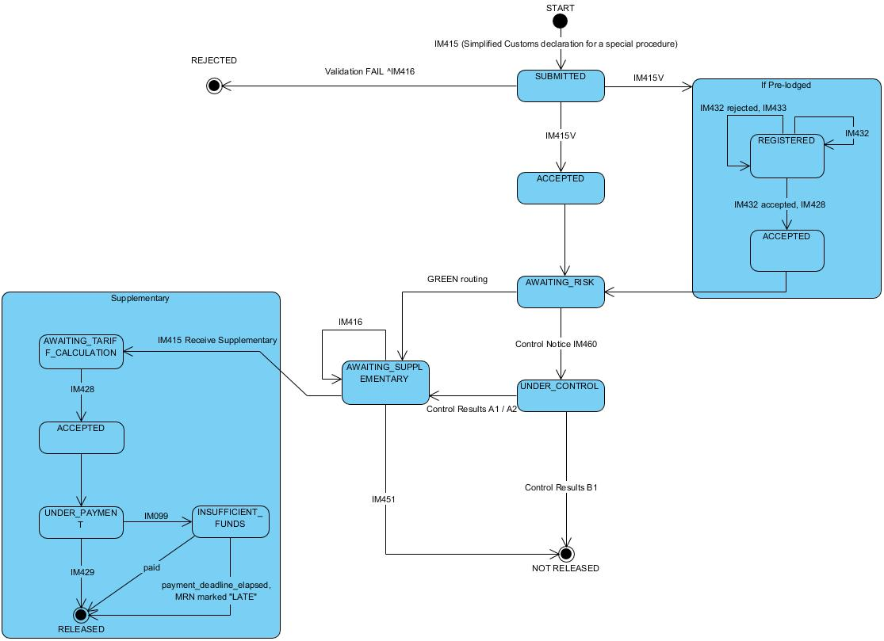

**Core Flow (Happy Path) - Placement – Post-lodged Simplified and Supplementary Customs Declaration**

1. AIS receives an IM415 message - Receive Simplified Customs Declaration for a Special Procedure
2. The declaration is post lodged
3. The message is syntactically valid
4. The message is logically valid (No business rules violation)
5. Declaration is evaluated as “arrived”
6. AIS sends IM428 acceptance message to the Trader
7. The declaration is Green routed or positive control results (after Alt 12 step 3)
8. AIS sends an IM429 Release Notification message to the Trader
9. AIS receives an IM415 message - Receive Supplementary Customs Declaration
10. The message is syntactically valid
11. The message is logically valid (No business rules violation)
12. AIS sends an IM428 acceptance message to the Trader
13. Payment process completed successfully
14. AIS sends an IM429 Release Notification message to the Trader

**Alt 1 - Simplified Customs Declaration is syntactically invalid**

1. The process follows the core flow up to step 1
2. The IM415 message is syntactically invalid
3. AIS sends an IM917 Syntax Error Notification message to the Trader

**Alt 2 - Simplified Customs Declaration is logically invalid**

1. The process follows the core flow up to step 2
2. The IM415 message is logically invalid (Business rules violation)
3. AIS sends an IM416 rejection message to the Trader

**Alt 3 – Simplified Customs Declaration is evaluated as “non-arrived”**

1. The process follows the core flow up to step 3
2. Simplified Customs Declaration is evaluated as “non-arrived”
3. AIS sends IM416 Rejection message

**Alt 4 - Simplified Customs Declaration – pre-lodged - Receive Presentation Notification**

1. The process follows the core flow up to step 1
2. Declaration is pre-lodged
3. The message is syntactically valid
4. The message is logically valid (No business rules violation)
5. AIS sends IM415V Registration acceptance message to the Trader
6. AIS receives the IM432 message
7. The message is syntactically valid
8. The message is logically valid (No business rules violation)
9. IM432 refers to an “arrived” declaration
10. AIS sends IM428 Application acceptance notification
11. The process follows the core flow up to step 7

**Alt 5 - Simplified Customs Declaration - The presentation notification is syntactically invalid**

1. The process follows the Alt 4 up to step 2
2. The IM415 message is syntactically invalid
3. AIS sends an IM917 Syntax Error Notification message to the Trader

**Alt 6 - Simplified Customs Declaration - Invalid presentation notification**

1. The process follows the Alt 4 up to step 3
2. The message is logically invalid (Business rules violation)
3. AIS sends an IM416 rejection message to the Trader

**Alt 7 – RED/ORANGE Routing**

1. The process follows the Alt 4 up to step 5
2. The Declaration is Orange/Red routed and AEO status
3. AIS sends an IM099 Declaration routing information to the Trader

**Alt 8 – Timer for presentation notification expired**

1. The process follows the Alt 4 up to step 5
2. Timer for presentation notification is expired
3. AIS sends an IM451 Release rejection

**Alt 9 – IM432 is syntactically invalid**

1. The process follows the Alt 4 up to step 6
2. IM432 is syntactically invalid
3. AIS sends an IM917 Syntax Error Notification message to the Trader

**Alt 10 –IM432 is logically invalid**

1. The process follows the Alt 4 up to step 7
2. IM432 is logically invalid
3. AIS sends an IM433 rejection message to the Trader

**Alt 11 – IM432 refers to a “non-arrived” declaration**

1. The process follows the Alt 4 up to step 8
2. IM432 refers to an “non-arrived” declaration
3. AIS sends an IM433 rejection message to the Trader

**Alt 12 – Red / Orange routing**

1. The process follows the core flow up to step 6
2. The declaration is red / orange routed
3. AIS sends an IM460 control notice message to the Trader

**Alt 13 – CERTEX certificate not finalised or under review**

1. The process follows the core flow up to step 7
2. CERTEX certificate not finalised or under review
3. AIS sends an IM099 information message to the Trader (Declaration under CERTEX verification)

**Alt 14 - Decision to release the Goods - Entry Refused**

1. The process follows the Alt 12 up to step 3
2. The Goods cannot be released
3. AIS sends an IM451 release rejection message to the Trader

**Alt 15 - Time limit for supplementary declaration: Timer for supplementary expired**

1. The process follows the core flow up to step 8
2. The timer for Supplementary declaration lodging expired
3. AIS sends an IM099 supplementary declaration timer expiration notification

**Alt 16 - Supplementary Customs Declaration is syntactically invalid**

1. The process follows the core flow up to step 9
2. The IM415 message is syntactically invalid
3. AIS sends an IM917 Syntax Error Notification message to the Trader

**Alt 17 – Supplementary Customs Declaration is logically invalid**

1. The process follows the core flow up to step 10
2. The IM415 message is logically invalid (Business rules violation)
3. AIS sends an IM416 rejection message to the Trader

**Alt 18 - Insufficient funds**

1. The process follows the core flow up to step 12
2. Customs debt is due, Trader’s account has insufficient funds
3. AIS sends an IM099 information message to the Trader (Insufficient funds)

### EIDR with PN and Supplementary Declaration (Type Z)

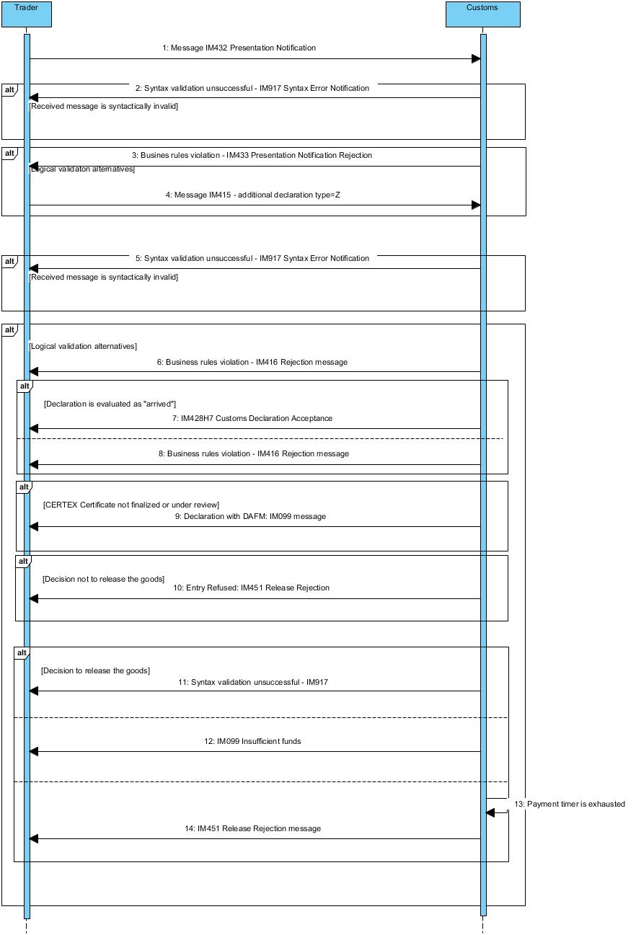

**Core Flow (Happy Path) - EIDR with Presentation notification**

1. AIS receives IM432 Presentation Notification
2. IM432 is syntactically valid
3. IM432 is logically valid
4. AIS receives an IM415 Supplementary Customs Declaration - Additional declaration type = Z message
5. The message is syntactically valid
6. The message is logically valid (No business rules violation)
7. The declaration is evaluated as “arrived”
8. AIS sends an IM428 acceptance message to the Trader
9. The payment process is completed successfully
10. AIS sends an IM429 release message to the Trader

**Alt 1 - IM432 is syntactically invalid**

1. The process follows the core flow up to step 1
2. IM432 is syntactically invalid
3. AIS sends an IM917 Syntax Error Notification message to the Trader

**Alt 2 – IM433 is logically invalid**

1. The process follows the core flow up to step 2
2. IM432 is logically invalid (Business rules violation)
3. AIS sends an IM433 rejection message to the Trader

**Alt 3 - The declaration is syntactically invalid**

1. The process follows the core flow up to step 4
2. The message is syntactically invalid
3. AIS sends an IM917 Syntax Error Notification message to the Trader

**Alt 4 - The declaration is logically invalid**

1. The process follows the core flow up to step 5
2. The message is logically invalid (Business rules violation)
3. AIS sends an IM416 rejection message to the Trader

**Alt 5 – The declaration is evaluated as “non-arrived”**

1. The process follows the core flow up to step 6
2. The declaration is evaluated as “non-arrived”
3. AIS sends an IM416 rejection message to the Trader

**Alt 6 – CERTEX Certificate not finalised or under review**

1. The process follows the core flow up to step 7
2. CERTEX Certificate is not finalised or under review
3. AIS sends an IM099 information message to the Trader (Declaration under CERTEX verification)

**Alt 7 - The Supplementary declaration is in ‘Insufficient funds’**

1. The process follows the core flow up to step 7
2. AIS sends an IM099 information message to the Trader (Insufficient funds)

**Alt 8 – Payment timer is exhausted**

1. The process follows the Alt 7 up to step 2
2. Payment timer is exhausted
3. AIS sends IM451 Release rejection message to the Trader

### EIDR with PN waiver and Supplementary Declaration (Type Z)

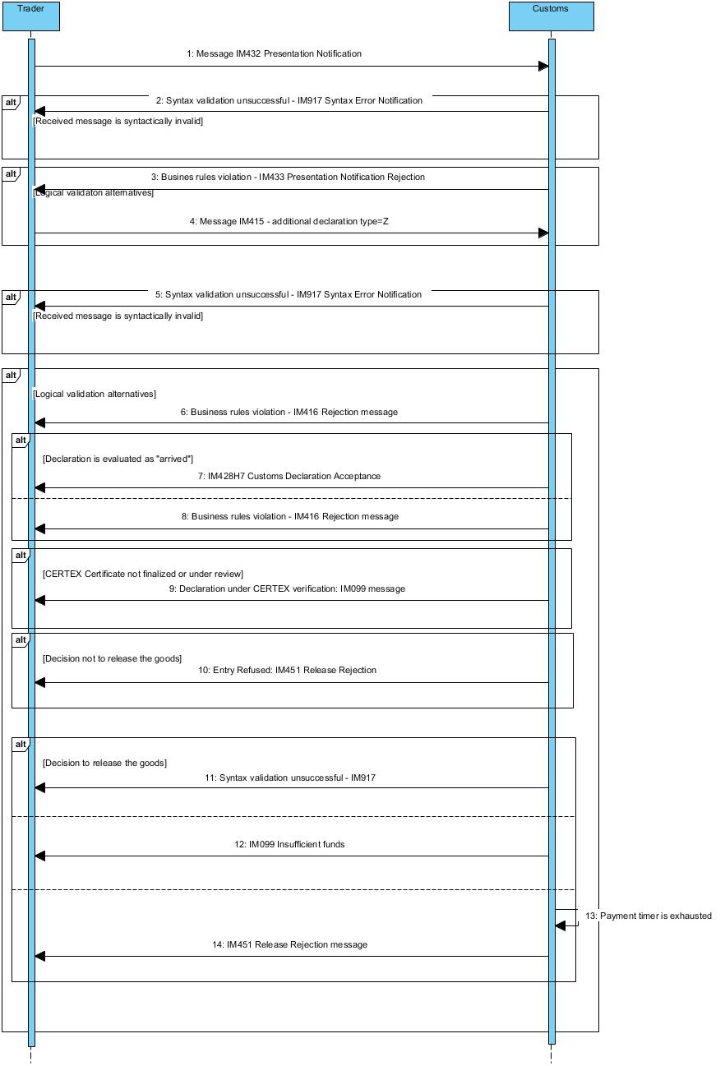

**Core Flow (Happy Path) - EIDR - Presentation notification waiver**

1. AIS receives an IM415 Supplementary Customs Declaration - Additional declaration type = Z message
2. The message is syntactically valid
3. The message is logically valid (No business rules violation)
4. The declaration is evaluated as “arrived”
5. AIS sends an IM428 acceptance message to the Trader
6. The payment process is completed successfully
7. AIS sends an IM429 release message to the Trader

**Alt 1 - The declaration is syntactically invalid**

1. The process follows the core flow up to step 1
2. The message is syntactically invalid
3. AIS sends an IM917 Syntax Error Notification message to the Trader

**Alt 2 - The declaration is logically invalid**

1. The process follows the core flow up to step 2
2. The message is logically invalid (Business rules violation)
3. AIS sends an IM416 rejection message to the Trader

**Alt 3 – The declaration is evaluated as “non-arrived”**

1. The process follows the core flow up to step 3
2. The declaration is evaluated as “non-arrived”
3. AIS sends an IM416 rejection message to the Trader

**Alt 4 – CERTEX Certificate not finalised or under review**

1. The process follows the core flow up to step 5
2. CERTEX Certificate is not finalised or under review
3. AIS sends an IM099 information message to the Trader (Declaration under CERTEX verification)

**Alt 5 - The Supplementary declaration is in ‘Insufficient funds’**

1. The process follows the core flow up to step 5
2. AIS sends an IM099 information message to the Trader (Insufficient funds)

**Alt 6 – Payment timer is exhausted**

1. The process follows the Alt 5 up to step 2
2. Payment timer is exhausted
3. AIS sends IM451 Release rejection message to the Trader

## Import Controls - Use Cases

### Request Declaration Amendment

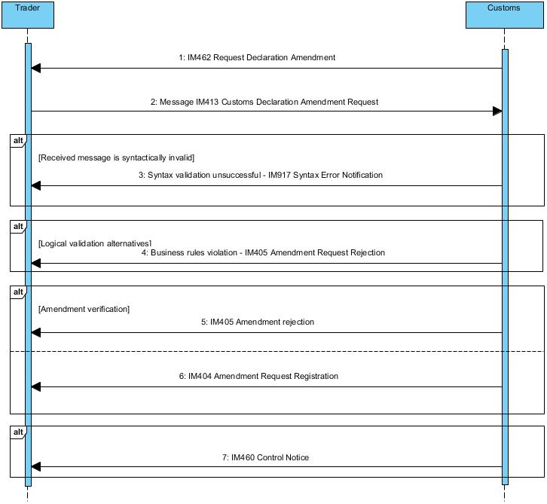

**Core Flow (Happy Path) – Customs request for declaration amendment**

1. AIS sends an IM462 Request Declaration Amendment message to the Trader
2. AIS receives an IM413 Customs Declaration Amendment Request message
3. The IM413 message is syntactically valid
4. The IM413 message is logically valid (No business rules violation)
5. Officer verifies and accepts the amendment
6. AIS sends an ΙΜ404 Amendment Request Registration message to the Trader
7. The declaration is Green routed

**Alt 1 - The amendment is syntactically invalid**

1. The process follows the core flow up to step 2
2. The IM413 message is syntactically invalid
3. AIS sends an IM917 Syntax Error Notification message to the Trader

**Alt 2 - The amendment is logically invalid**

1. The process follows the core flow up to step 3
2. The IM413 message is logically invalid (Business rules violation)
3. AIS sends an IM405 Amendment Request Rejection message to the Trader

**Alt 3 – Officer rejects amendment**

1. The process follows the core flow up to step 4
2. Officer rejects amendment
3. AIS sends an IM405 Amendment Request Rejection message to the Trader

**Alt 4 – RED/ORANGE Routing**

1. The process follows the core flow up to step 6
2. The Declaration is Orange/Red routed
3. AIS sends an IM460 Control Notice message to the Trader

### Request Declaration Invalidation

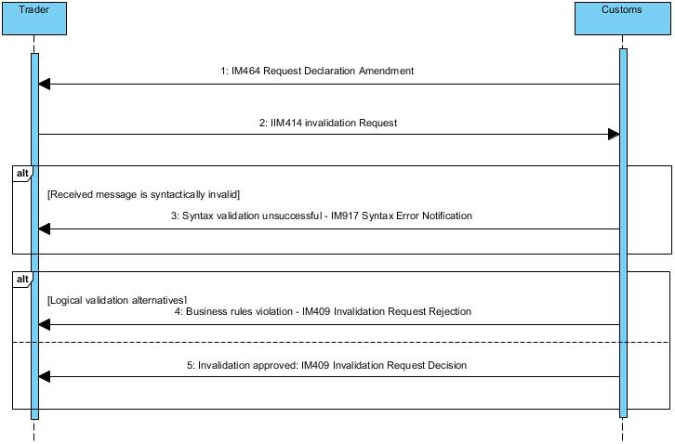

**Core Flow (Happy Path) - Request declaration invalidation**

1. AIS sends an IM464 Request Declaration Invalidation message to the Trader
2. AIS receives an IM414 Invalidation Request message
3. The message is syntactically valid
4. The message is logically valid (No business rules violation)
5. AIS sends an ΙΜ409 “Positive” Invalidation Request Decision message to the Trader

**Alt 1 - The amendment is syntactically invalid**

1. The process follows the core flow up to step 2
2. The IM414 message is syntactically invalid
3. AIS sends an IM917 Syntax Error Notification message to the Trader

**Alt 2 - The amendment is logically invalid**

1. The process follows the core flow up to step 3
2. The IM414 message is logically invalid (Business rules violation)
3. AIS sends an IM409 Invalidation “Negative” Request Decision message to the Trader

### Request Document Presentation

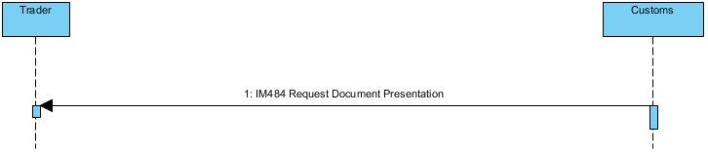

**Core Flow (Happy Path) - Request document presentation**

1. AIS sends an IM484 Request Document Presentation message to the Trader
2. The requested documents must be physically presented at any Customs Office

### Request Document Upload

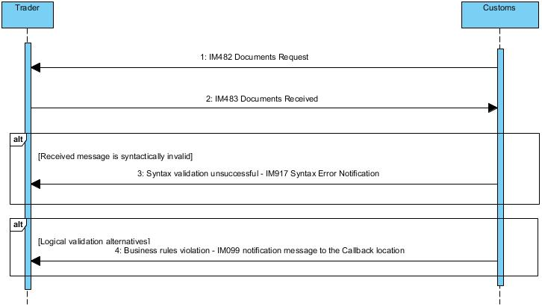

**Core Flow (Happy Path) - Request document upload**

1. AIS sends an IM482 Documents Request message to the Trader
2. AIS receives an IM483 Documents Received message
3. The message is syntactically valid
4. The message is logically valid (No business rules violation)

**Alt 1 - The upload is syntactically invalid**

1. The process follows the core flow up to step 2
2. The IM483 message is syntactically invalid
3. AIS sends an IM917 Syntax Error Notification message to the Trader

**Alt 2 - The upload is logically invalid**

1. The process follows the core flow up to step 3
2. The IM483 message is logically invalid (Business rules violation)
3. AIS sends an IM099 notification message to the Trader with specific logical error(s) description

## Quota Allocation – Use Cases

### Amendment notification for partial or deferred quota allocation

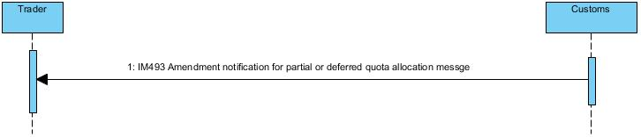

**Core Flow (Happy Path) - Amendment notification for partial or deferred quota allocation**

1. AIS sends an IM493 Amendment notification for partial or deferred quota allocation message to the Trader

# Excise Duty Declaration (ND1)

## Messages

See 2.6, 2.9, and 2.10

## Use Cases

### ND1 Declaration

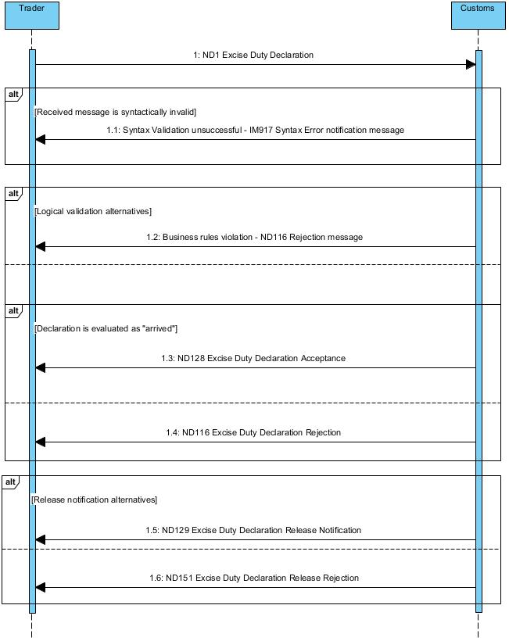

#### ND1 Declaration for goods that are concerned only by national taxes

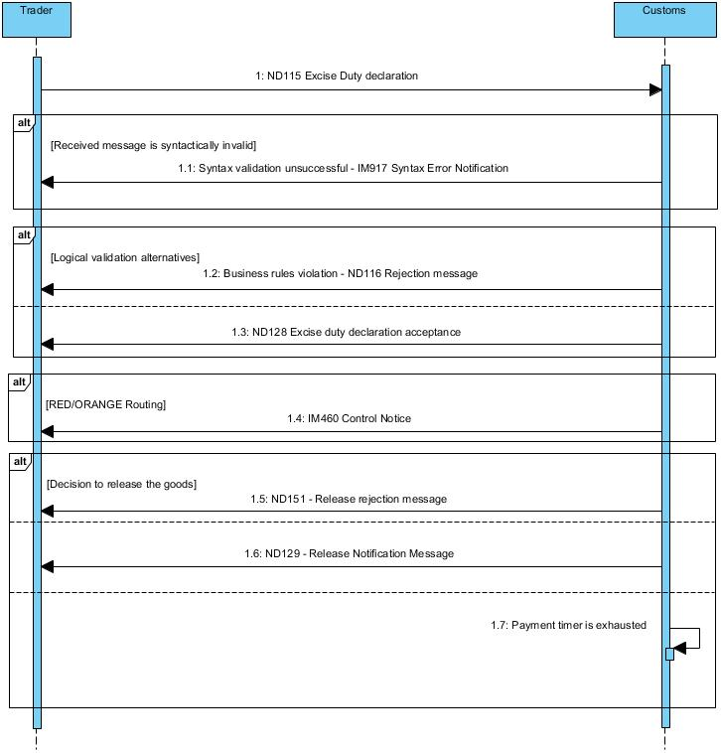

**Core Flow (Happy Path) – ND1 Declaration for goods that are concerned only by national taxes**

1. AIS receives a ND115 message
2. The message is syntactically valid
3. The message is logically valid (No business rules violation)
4. The declaration is accepted
5. AIS sends the ND128 acceptance message to the Trader
6. The declaration is Green routed
7. The goods are released for free circulation
8. The declaration is set to status “RELEASED”
9. AIS sends the ND129 release message to the Trader
10. A 10-days timer is set to the declaration for the reception of the payment confirmation

**Alt 1 - The declaration is syntactically invalid**

1. The process follows the Core Flow up to step 1
2. The ND115 message is syntactically invalid
3. AIS sends an IM917 Syntax Error message to the Trader

**Alt 2 - The declaration is logically invalid**

1. The process follows the Core Flow up to step 2
2. The ND115 message is logically invalid (Business rules violation)
3. AIS sends an ND116 rejection message to the Trader

**Alt 3 – RED/ORANGE Routing**

1. The process follows the Core Flow up to step 5
2. The Declaration is Red/Orange routed
3. AIS sends an IM460 Control Notice message to the Trader

**Alt 3.1 – Control Decision - Entry Refused**

1. The process follows the Alt 3 up to step 3
2. The Goods cannot be released
3. AIS sends an ND151 release rejection message to the Trader

**Alt 3.2 – Control Decision - Entry Permitted**

1. The process follows the Alt 3 up to step 3
2. The Goods can be released
3. AIS sends an ND129 release notification message to the Trader

**Alt 4 - Timer for payment expired**

1. The process follows the Core flow up to step 9
2. Trader has failed to fulfil their financial obligation to Customs within the specified time-limit
3. Manual Customs intervention is needed in order to handle this case

#### ND1 Declaration for goods that are concerned by EU taxes

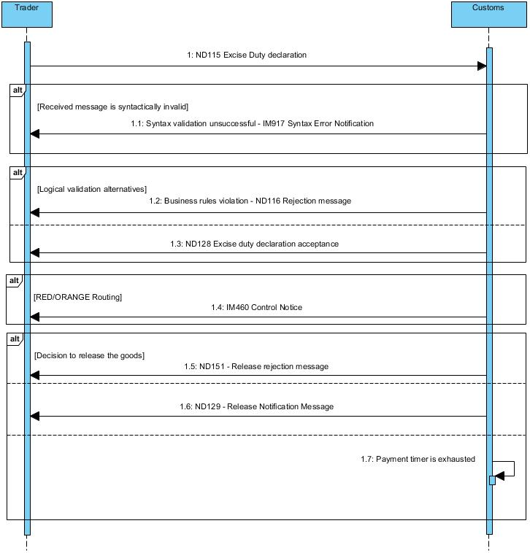

**Core Flow (Happy Path) – ND1 Declaration for goods that are concerned by EU taxes**

1. AIS receives a ND115 message
2. The message is syntactically valid
3. The message is logically valid (No business rules violation)
4. The declaration is accepted
5. AIS sends an ND128 acceptance message to the Trader
6. The declaration is Green routed
7. The payment request is sent to the Accounting System
8. One-day timer is set to the declaration for the reception of the payment confirmation
9. The payment confirmation is received from the Accounting System
10. The goods are released for free circulation
11. The declaration is set to status “RELEASED”
12. AIS sends the ND129 release message to the Trader

**Alt 1 - The declaration is syntactically invalid**

1. The process follows the Core Flow up to step 1
2. The ND115 message is syntactically invalid
3. AIS sends an IM917 Syntax Error message to the Trader

**Alt 2 - The declaration is logically invalid**

1. The process follows the Core Flow up to step 2
2. The ND115 message is logically invalid (Business rules violation)
3. AIS sends an ND116 rejection message to the Trader

**Alt 3 – RED/ORANGE Routing**

1. The process follows the Core Flow up to step 5
2. The Declaration is Red/Orange routed
3. AIS sends an IM460 Control Notice message to the Trader

**Alt 3.1 – Control Decision - Entry Refused**

1. The process follows the Alt 3 up to step 3
2. The Goods cannot be released
3. AIS sends an ND151 release rejection message to the Trader

**Alt 3.2 – Control Decision - Entry Permitted**

1. The process follows the Alt 3 up to step 3
2. The Goods can be released
3. AIS sends an ND129 release notification message to the Trader

**Alt 4 - Timer for payment expired**

1. The process follows the Core flow up to step 8
2. The payment confirmation was not received within the specified time-limit
3. Customs intervention is needed. The Declaration will be set to [RELEASED] only after manual approval from Customs.

### Amendment to the ND1 Declaration

**Note:** An amendment to the ND1 declaration can be done only after request from Customs.

#### Amendment request before release

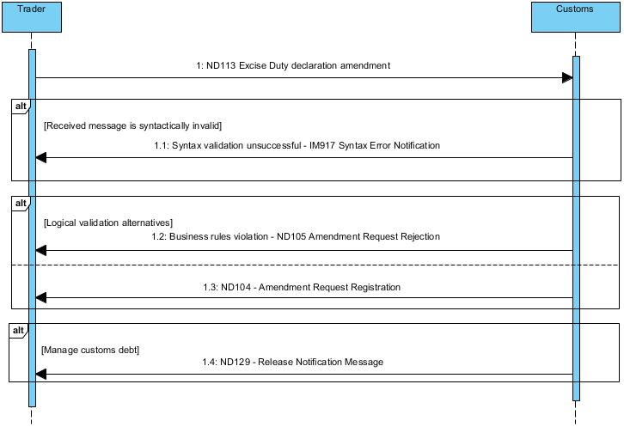

**Core Flow (Happy Path) - Amendment of the ND1 Declaration**

1. AIS receives a ND113 message
2. The message is syntactically valid
3. The message is logically valid (No business rules violation)
4. No reduction in liability or reduced liability business case accepted
5. AIS sends the ND104 acceptance message to the Trader
6. The declaration is Green routed
7. The payment process is completed successfully
8. The Goods can be released
9. AIS sends the ND129 release notification message to the Trader

**Alt 1 - The request is syntactically invalid**

1. Process follows the Core Flow up to step 1
2. The ND113 message is syntactically invalid
3. AIS sends an IM917 Syntax Error Notification message to the Trader

**Alt 2 - The request is logically invalid**

1. Process follows the Core Flow up to step 2
2. The ND113 message is logically invalid (Business rules violation)
3. AIS sends an ND105 Amendment Request Rejection message to the Trader

**Alt 3 – Amendment request rejected after review**

1. The process follows the core flow up to step 3
2. The amendment cannot be accepted
3. AIS sends ND105 Amendment Request Rejection message to the Trader

**Note:** After the acceptance of the amendment request, it is processed as a normal ND1 declaration (i.e., the alternative scenarios of the ND1 declaration apply).

#### Amendment request after release

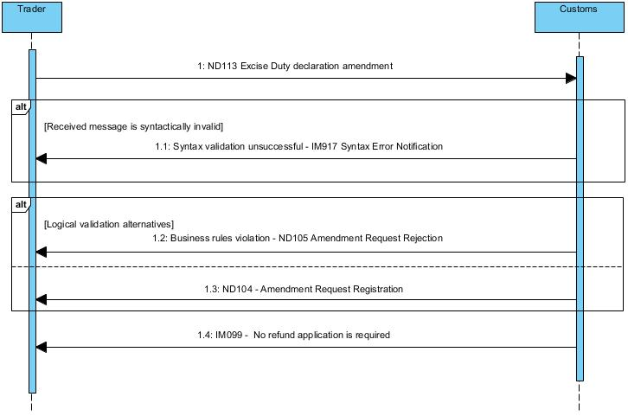

**Core Flow – Amendment of the Customs Declaration (Post release)**

1. AIS receives a ND113 message
2. The message is syntactically valid
3. The message is logically valid (No business rules violation)
4. The invalidation is accepted
5. AIS sends the ND104 Amendment Request Decision - request acceptance message to the Trader
6. No refund is required
7. AIS sends the IM099 information message the Trader (No refund application required)

**Alt 1 - The request is syntactically invalid**

1. Process follows the Core Flow up to step 1
2. The ND113 message is syntactically invalid
3. AIS sends the IM917 Syntax Error Notification message to the Trader

**Alt 2 - The request is logically invalid**

1. Process follows the Core Flow up to step 2
2. The ND113 message is logically invalid (Business rules violation)
3. The amendment is rejected
4. AIS sends the ND105 Amendment Request Decision - request rejected message to the Trader

#### Invalidation of the ND1 Declaration

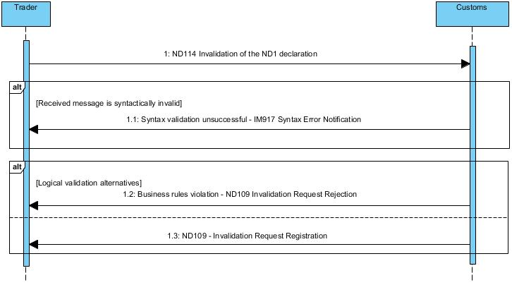

**Core Flow – Invalidation of the ND1 Declaration**

1. AIS receives an ND114 message
2. The message is syntactically valid
3. The message is logically valid (No business rules violation)
4. The invalidation is accepted
5. AIS sends the ND109 Invalidation Request Decision - request acceptance message to the Trader

**Alt 1 - The request is syntactically invalid**

1. Process follows the Core Flow up to step 1
2. The ND114 message is syntactically invalid
3. AIS sends an IM917 Syntax Error Notification message to the Trader

**Alt 2 - The request is logically invalid**

1. Process follows the Core Flow up to step 2
2. The ND114 message is logically invalid (Business rules violation)
3. The invalidation is rejected
4. AIS sends an ND109 Invalidation Request Decision - request rejected message to the Trader

# Means of Transport Declaration (ND2)

## Messages

See 2.7, 2.9, and 2.10

## Use Cases

### ND2 Means of Transport Declaration

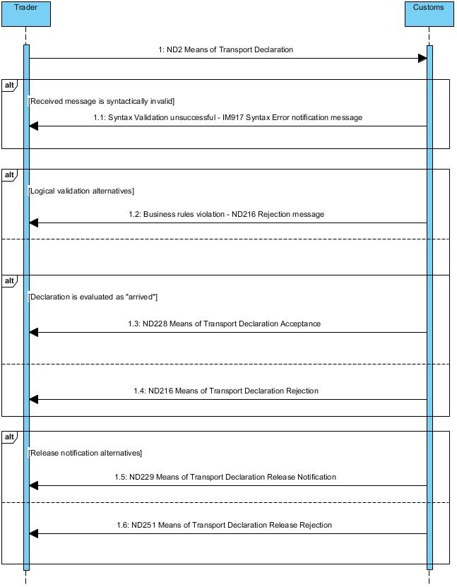

#### ND2 declaration for new vehicles

**Core Flow (Happy Path) – ND2 Declaration for new vehicles**

1. AIS receives a ND215 message
2. The message is syntactically valid
3. The message is logically valid (No business rules violation)
4. The declaration is accepted
5. AIS sends an ND228 acceptance message to the Trader
6. The declaration is Green routed
7. The payment request is sent to the Accounting System
8. The payment confirmation is received from the Accounting System
9. The goods are released for free circulation
10. The declaration is set to status “RELEASED”
11. AIS sends the ND229 release message to the Trader

#### ND2 declaration for used vehicles

**Core Flow (Happy Path) – ND2 Declaration for used vehicles**

1. AIS receives a ND215 message
2. The message is syntactically valid
3. The message is logically valid (No business rules violation)
4. The declaration is accepted
5. AIS sends the ND228 acceptance message to the Trader
6. The declaration is Green routed
7. The goods are released for free circulation
8. The declaration is set to status “RELEASED”
9. AIS sends the ND229 release message to the Trader
10. A 10-days timer is set to the declaration for the reception of the payment confirmation

### Amendment to the ND2 Declaration

Same use cases as for the ND1 declaration (using the corresponding ND2* messages)

### Invalidation of the ND2 Declaration

Same use cases as for the ND1 declaration (using the corresponding ND2* messages)

# Proof of Union Status (ND3)

## Messages

See 2.8, 2.9, and 2.10

## Use Cases

### ND3 Declaration

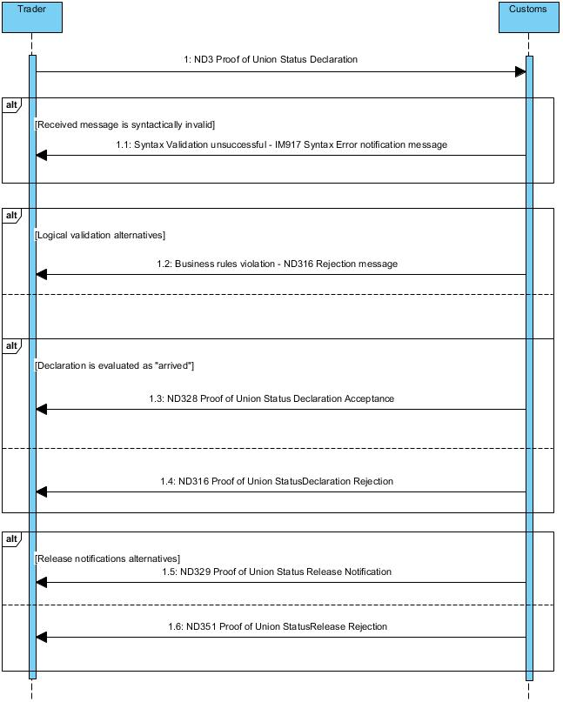

**Core Flow (Happy Path) – ND3 Declaration**

1. AIS receives a ND315 message
2. The message is syntactically valid
3. The message is logically valid (No business rules violation)
4. The declaration is accepted
5. AIS sends an ND328 acceptance message to the Trader
6. The declaration is Green routed
7. The goods are released for free circulation
8. The declaration is set to status “RELEASED”
9. AIS sends the ND329 release message to the Trader

**Alt 1 - The declaration is syntactically invalid**

1. The process follows the Core Flow up to step 1
2. The ND315 message is syntactically invalid
3. AIS sends an IM917 Syntax Error message to the Trader

**Alt 2 - The declaration is logically invalid**

1. The process follows the Core Flow up to step 2
2. The ND315 message is logically invalid (Business rules violation)
3. AIS sends an ND316 rejection message to the Trader

**Alt 3 – RED/ORANGE Routing**

1. The process follows the Core Flow up to step 5
2. The Declaration is Red/Orange routed
3. AIS sends an IM460 Control Notice message to the Trader

**Alt 3.1 – Control Decision - Entry Refused**

1. The process follows the Alt 3 up to step 3
2. The Goods cannot be released (i.e. their Union Status was not proved)
3. AIS sends an ND351 release rejection message to the Trader

**Alt 3.2 – Control Decision - Entry Permitted**

1. The process follows the Alt 3 up to step 3
2. The Goods can be released
3. AIS sends an ND329 release notification message to the Trader

### Amendment to the ND3 Declaration

Same use cases as for the ND1 declaration (using the corresponding ND3* messages)

### Invalidation of the ND3 Declaration

Same use cases as for the ND1 declaration (using the corresponding ND3* messages)

# Typical scenarios for the Import of Goods

The sections below present the most common scenarios for the Import of goods and the flow of messages between Traders and Customs.

We present only the messages that Traders have to submit, without the Customs reply messages. For the complete list of exchanged messages, refer to the user cases of the corresponding message.

## Non-Union Goods - standard procedure

The standard procedure covers both maritime and air freight.

### Placement of Goods under Temporary Storage

Traders can place non-Union goods under Temporary Storage using either:

* a separate G4 temporary storage declaration, before the actual arrival of the goods
* a combined G4+G3 temporary storage declaration when the goods will be presented to Customs

Optionally, the goods that are under Temporary Storage can be:

* deconsolidated, using the deconsolidation process (see section 4.2)
* moved to another TS facility, using the movement process (see section 4.3)

#### Using a G4 Temporary Storage Declaration

| **Seq.** | **Type[2]** | **Message** | **Comments** |
| --- | --- | --- | --- |
| 1 | M | TS315 | The Trader (responsible for the submission of the temporary storage declaration) submits a G4 temporary storage declaration announcing to Customs the goods that will be placed under the Temporary Storage |
| 2 | M | AN215 | The Carrier submits the arrival notification announcing the arrival of the means of transport in the Cyprus port/airport. |
| 3 | M | TS332 | The Trader (responsible for the presentation of the goods that will be placed under temporary storage) submits the presentation notification.  The presentation notification shall reference the arrival notification. |
| 4 | M | TS370 | The responsible of the TS facility presents the status report for the goods announced in the G4 temporary storage declaration. |
| 5 | O | ND515 | Deconsolidation of goods under temporary storage |
| 6 | O | TS515  TS501 | Request Movement of goods under temporary storage  Notification of movement of goods under temporary storage |

#### Using a G4+G3 Temporary Storage Declaration

| **Seq.** | **Type** | **Message** | **Comments** |
| --- | --- | --- | --- |
| 1 | M | AN215 | The Carrier submits the arrival notification announcing the arrival of the means of transport in the Cyprus port/airport. |
| 2 | M | TS315 | The Trader (responsible for the submission of the temporary storage declaration) submits a G4+G3 temporary storage declaration announcing to Customs the goods that will be placed under the Temporary Storage.  The G4+G3 temporary storage declaration shall reference the arrival notification. |
| 3 | M | TS370 | The responsible of the TS facility sends to Customs the status report for the goods announced in the G4 temporary storage declaration. |
| 4 | O | ND515 | Deconsolidation of goods under temporary storage |
| 5 | O | TS515  TS501 | Request Movement of goods under temporary storage  Notification of movement of goods under temporary storage |

### Release Goods for free circulation

Traders can release goods that are placed under Temporary Storage for free circulation using one of the following ways:

* Using the ND1 national declaration when the goods are subject to Excise Duties
* Using the ND2 national declaration when the goods concern means of transport
* Using the ND3 national declaration when the goods are Union goods.
* Using the standard import declarations (H1-H5, H7) for any other case of non-Union goods

| **Seq.** | **Type** | **Message** | **Comments** |
| --- | --- | --- | --- |
| 1 | M | IM415  ND115  ND315 | Request release to free circulation with one of the following:   * Import declaration (H1-H5, H7) * National declaration for Excise Duties (ND1) * National declaration for Proof of Union Status (ND3) |

## Union Goods – Standard Procedure

According to the provisions of the national legislation and for the needs of the risk analysis, means of transports that arrive directly from another Member State (i.e., transfer of Union goods, which keep their Union status) will declare their load using a national declaration for Union Goods (Manifest).

| **Seq.** | **Type** | **Message** | **Comments** |
| --- | --- | --- | --- |
| 1 | M | AN215 | The Carrier submits the arrival notification announcing the arrival of the means of transport in the Cyprus port/airport. |
| 2 | M | TS315 | The Trader submits the Union Goods declaration announcing to Customs the arrival of the goods.  The Union Goods declaration shall reference the arrival notification.  The goods will be released for free circulation upon acceptance of the declaration by Customs. If needed, Customs may decide to control the goods or request additional/supporting documents. |

## Postal and Courier Service Providers

### Postal cargo with delivery at the Office of Exchange

**Note:** The Office of Exchange is authorised temporary storage facility.

| **Seq.** | **Type** | **Message** | **Comments** |
| --- | --- | --- | --- |
| 1 | M | ENS | The ENS (Entry Summary Declaration) must be submitted via the ICS2 system (Shared Trader Interface) |
| 2 | M | TS315 | The postal service provider submits the G4 temporary storage declaration with reference to the ENS declaration[3] |
| 3 | M | AN | The AN (Arrival Notification) must be submitted via the ICS2 system (Shared Trader Interface) |
| 4 | M | TS332 | The postal service provider submits the G3 presentation notification (CY-AIS will forward automatically the G3 presentation notification to CY-ICS2) |
| 5 | M | TS370 | The Office of Exchange sends to Customs the status report for the goods announced in the G4 temporary storage declaration. |
| 6 | O | ND515 | Deconsolidation of goods under temporary storage |
| 7 | M | IM415  ND115  ND315 | Request release to free circulation with one of the following:   * Import declaration (H1-H5, H7) * National declaration for Excise Duties (ND1) * National declaration for Proof of Union Status (ND3) |

### Postal cargo with transfer from the Office of Exchange to the MSC

**Note:** The Office of Exchange and the Mail Sorting Centre (MSC) are authorised temporary storage facilities.

| **Seq.** | **Type** | **Message** | **Comments** |
| --- | --- | --- | --- |
| 1 | M | ENS | The ENS (Entry Summary Declaration) must be submitted via the ICS2 system (Shared Trader Interface) |
| 2 | M | TS315 | The postal service provider submits the G4 temporary storage declaration with reference to the ENS declaration |
| 3 | M | AN | The AN (Arrival Notification) must be submitted via the ICS2 system (Shared Trader Interface) |
| 4 | M | TS332 | The postal service provider submits the G3 presentation notification (CY-AIS will forward automatically the G3 presentation notification to CY-ICS2) |
| 5 | M | TS370 | The Office of Exchange sends to Customs the status report for the goods announced in the G4 temporary storage declaration. |
| 6 | M | TS515  TS501 | The Office of Exchange requests the move of the goods to MSC  MSC announces to Customs the transfer |
| 7 | M | ND515 | Deconsolidation of the goods in MSC |
| 8 | M | IM415  ND115  ND315 | Request release to free circulation with one of the following:   * Import declaration (H1-H5, H7) * National declaration for Excise Duties (ND1) * National declaration for Union Goods (ND3) |

### Couriers

| **Seq.** | **Type** | **Message** | **Comments** |
| --- | --- | --- | --- |
| 1 | M | ENS | The ENS (Entry Summary Declaration) must be submitted via the ICS2 system (Shared Trader Interface) |
| 2 | M | TS315 | The courier service provider submits the G4 temporary storage declaration with reference to the ENS declaration[4] |
| 3 | M | AN | The AN (Arrival Notification) must be submitted via the ICS2 system (Shared Trader Interface) |
| 4 | M | TS332 | The courier service provider submits the G3 presentation notification (CY-AIS will forward automatically the G3 presentation notification to CY-ICS2) |
| 5 | M | TS370 | The TS administrator sends to Customs the status report for the goods announced in the G4 temporary storage declaration. |
| 6 | O | ND515 | Deconsolidation of the goods under temporary storage |
| 7 | O | TS515  TS501 | Request Movement of goods under temporary storage  Notification of movement of goods under temporary storage |
| 8 | M | IM415 | Request release to free circulation with one of the following:   * Import declaration (H1, H7) |

# Exchange of Messages

This section presents a high-level description of the message exchange process in the context of the B2G communication. The detailed technical specifications of the B2G communication protocol will be provided in a separate document.

## B2G Communication Protocol

The communication with the Traders that will use the B2G interface will be done via the Cyprus electronic Government Gateway (see [R03]).

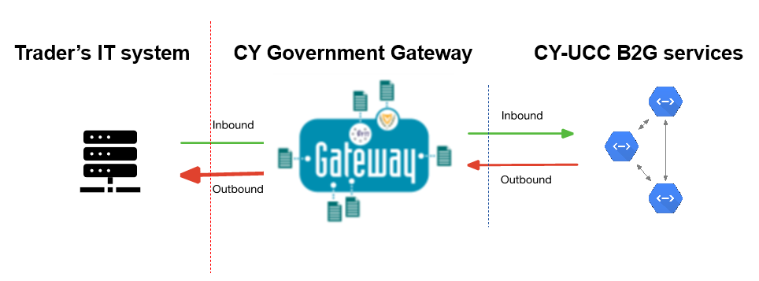

Figure 7: B2G communication overview

The Traders that will use the B2G interface shall first register to DITS for the use of the B2G service. Their EORI number shall be also registered in CY-CAS.

The CY-UCC B2G service will expose the following services:

* Submission of the messages that are sent by the Trader to Customs
* Query of the status of a specific message that was sent by the Trader to Customs
* Query of the status of an MRN
* Downloading of the messages that are sent by the CY-UCC systems to the Trader

For all the services, the synchronous message pattern will be used, as defined in [R03].

### Submission of the messages

The body of the request shall contain the message that the Trader wants to submit to Customs. Only one message per request will be allowed.

As soon as the CY-UCC B2G service receives the message, it will return to the Trader’s IT system the response with the status of the request.

If there were no technical errors in the processing of the message, a unique communication ID, will be included in the response. That unique ID will have to be used for the status follow-up.

### Query of the status of a specific message

The Trader IT system shall query in regular intervals the CY-UCC B2G service, using the unique communication Identifier that was returned by the message submission service, in order to retrieve the status of their request. If the request is accepted, the response will contain also the MRN.

### Query using the MRN

The Trader IT system may query the CY-UCC B2G service, using the MRN (Movement Reference Number) of a movement. If the Trader has the necessary access rights for that movement, the system will return a list with the status and the communication ID for all the messages that are linked to the given MRN (e.g. request for additional documents, control notifications, etc.).

### Message Downloading

The service will allow the Trader IT system to download a message (in XML format) using the message ID (as returned from one of the status query services).

**END OF THE DOCUMENT**

1. Throughout this document the term **Trader** refers to the economic operators that will use the B2G (system-to-system) interface for the submission of their declarations.
2. M: mandatory O: optional
3. Alternatively, the postal service provider can submit the combined G4+G3 declaration at step 4.
4. Alternatively, the courier service provider can submit the combined G4+G3 declaration at step 4.